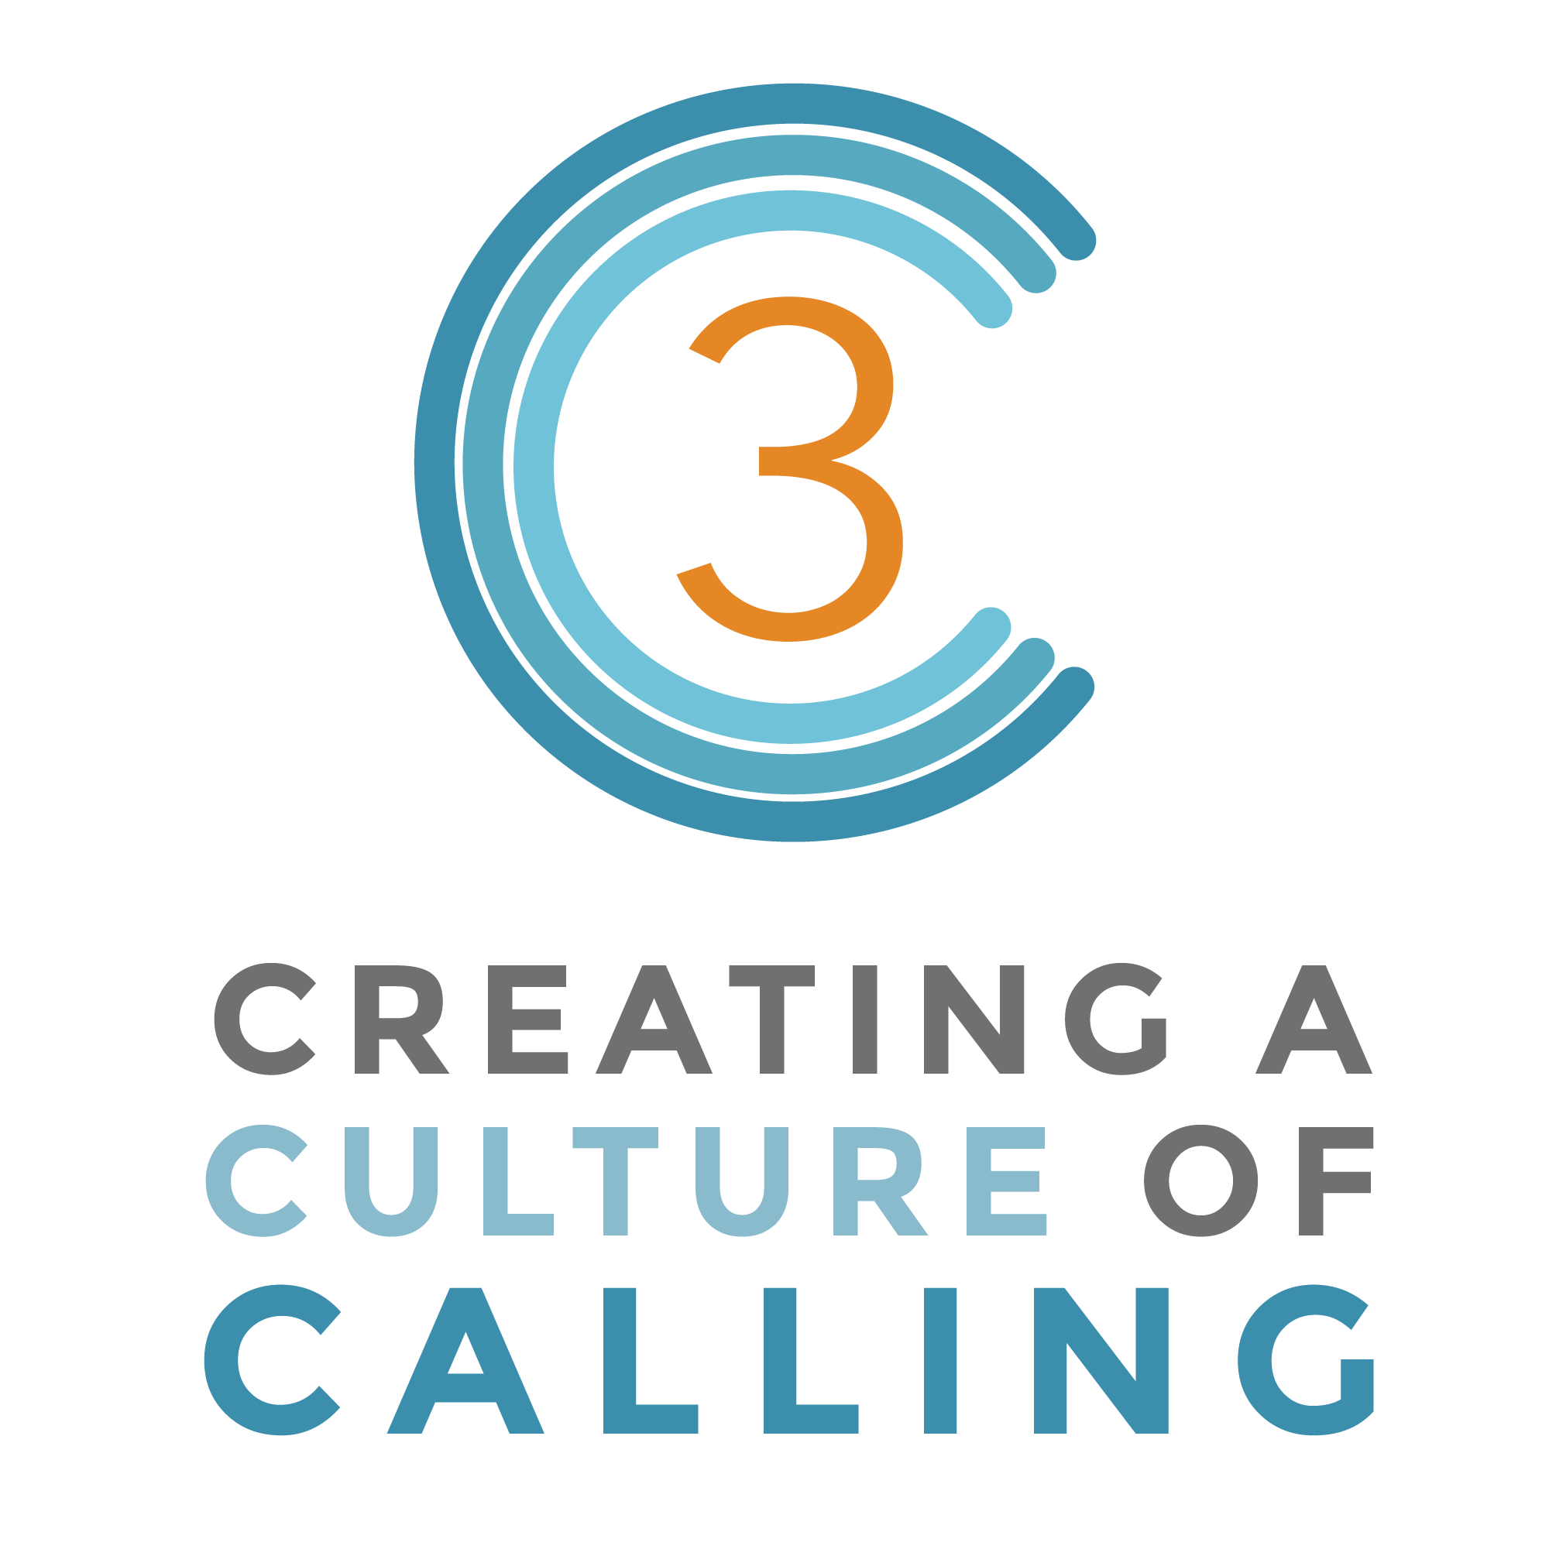

Young Adult & Adult Faith Formation Program

Becoming Instruments of God Session

Living one’s calling means becoming an instrument of God in our relationships, our families, our workplace, our communities, and our world. Discover how to grow as an instrument of God.

Watch: Rhythm by Rob Bell

Begin by watching the video Rhythm with Rob Bell (NOOMA 011): https://vimeo.com/195478652.
(You can purchase a digital version from: https://www.zondervan.com/rhythm-011-rob-bell)

After watching the video, invite the group to share the emotions or feelings that surfaced while watching the video. Then, invite them to share insights they discovered while watching the video.

Present

Share with the group the following thoughts about being an instrument of God from Joyce Rupp (​May I Have This Dance. Joyce Rupp. Ave Maria Press, 1992)

I become an instrument of God when I let go of my own need to have everything go well or to avoid failure to please others or simply to make more money. I become God's song when I open up and trust God's energy moving through me will create goodness and harmony through who and how I am.

Much of discovering God's presence in the work world depends on our understanding of where and how God is to be found. Who are we looking for when we look for God, where do we expect to find God?
Can we pause and believe that God is breathing strength and goodness in our spirits so that we can approach our lives with more hope and courage?
Imagine how differently we might live our lives if, each day when we awakened, we envisioned ourselves as instruments of God. We would know each day that we were not alone. We would drawn comfort and joy from the divine musician making a melody of goodness with our gifts and talents.

If there are days when we doubt our ability to be instruments of God's love, there are also times when we experience this truth very clearly. These are the days when:

- someone thanks us for something we've done that helped them significantly, even though we did not realize that we had done anything out of the ordinary
- we sense a deep harmony and oneness within for no particular reason
- we fell a strength within that we know is not ours alone
- we experience a bonding with people with whom we live or work that goes beyond personalities and human perceptions
- we discover and claim a gift or an ability of ours because of its effect on others' lives​

Reflect

Engage the group in experiencing one or more of the following activities (from ​May I Have This Dance. Joyce Rupp. Ave Maria Press, 1992)

Activity #1.
Reflect on your life as an instrument of God. What kind of instrument would you be? A flute, a piano, a trumpet, a sax, a drum, a violin, a clarinet? What draws you to see yourself this way?
What kind of music is God playing in your life now? A golden oldie, a spirited march, a dissonant piece, a dirge, a lullaby, a rock song, hip hop, rap, a ballad? What song title sums up the way God has been a part of your life?
Activity #2
Reflect on Martin Buber's thought: "It is not the nature of the task but the consecration that is the vital thing? What motivates your work and your daily activities? Why do you do what you do?
Write a dedication or a consecration of yourself and your work to God. Share this with someone you trust. Let it be the proclamation of your promise to be an instrument of God. (You may want to fit a familiar melody to the your words of dedication. You could then play or sing the dedication.)
Activity #3
Draw a musical instrument. Around it write words for the many melodies that God has has played in your life in the past ten years. These words might include events, people whose lives you have influenced, gifts or talents you have developed, ideas and insights that you have changed your approach to life, and so on.
Activity #4
Who are the people you have known who were instruments of God for you or for others? What kind of melodies did you hear in their lives? How did these melodies affect your life?

Pray

A Litany of Being God's Instrument of Goodness
For the talents and the abundance of gifts that are ours.... We thank you.

For the faith that stirs and grows in our hearts....
We thank you.

For the many people who have been your instruments of goodness in our lives....
We thank you.
For the moments we have know the song of your presence in a special way....
We thank you.
For the times when your goodness has made music through us....
We thank you.
When fear rises up in us and we do not believe in our ability to be your instrument....
Help us trust in you.
When the busyness and schedules of our lives press upon us and create questions about your song with us....
Help us trust in you.
​When we doubt your presence in the difficult aspects of our days....
Help us trust in you.
When we lose sight of the trust that we are called to be instruments of goodness....
Help us trust in you.
When emptiness, loneliness, and other struggles keep us from hearing your melody of love....
Help us trust in you.
Closing Prayer
"Glory be to God whose power, working in us, can do infinitely more than we can ask or imagine." (Ephesians 3:21) Amen.
​(May I Have This Dance. Joyce Rupp. Ave Maria Press, 1992)

