+Cross-generational Session

**The Living Word - Jesus**

Here is a cross-generational session for all members of the congregation exploring the Living Word of God and the Bible. This session is designed to be conducted in about 90 minutes, and can be adapted for a shorter or longer timeframe.

**Introduction**

The Bible tells us that Jesus is God’s Word, made flesh. In other words, Jesus’ life and ministry are our best way of understanding God. These activities provide a way for families to become more familiar with the Bible and get to know some basics in a fun, interactive way.

**I. Gather**

**Needed**

Bible

**Prepare in Advance**

* Mark your Bible to John 1 (or see text below)

**Activity Plan**

1. Think about words. Discuss in family groups:

* What’s a word? What do words do?
* If you could see and talk to God right now, what words would you say? What would God say?

1. Read John 1:1-2 and 1:14

“In the beginning was the Word, and the Word was with God, and the Word was God. He was in the beginning with God. All things were made through him . . . And the Word became flesh and dwelt among us.”

* Re-read the text and say “Jesus” instead of “The Word.”
* What does this text tell us about Jesus?

1. All together, say this prayer aloud.

*God, thank you for giving us your Word. Be with us during this fun time of solving the puzzle and help us to learn more about your love for us in the Bible. Amen.*

**II. Grow**

[use an adaptation of the activity Know Your Bible Puzzle

**Needed:**

* Pencils
* Know Your Bible Puzzle (cut in pieces) – one for each family or small group
* Decoder Sheet – one for each family or small group

**Activity Plan**

1. Say the following to the group:

Sometimes the Bible can feel like a puzzle, because it can be hard to understand things or even find what you are looking for. In your family or small groups, share with each other: has there been a time when you have encountered something in the Bible that you didn’t understand? What was it?

1. Work together to complete the puzzle by matching the two correct parts of the sentence. For example: If one square said, “Jesus was born” and another said “in Bethlehem” you would line up those to squares as shown so it completes the sentence correctly. Use the swirl pattern on the squares to check that they match up.
2. Now that you have the puzzle completed it’s time to decode the message. Do not take apart your puzzle yet, you’ll still need it together! On your decoder sheet you’ll see two rows of symbols. Find the square that has a matching symbol to the first symbol on the decoder sheet. If the puzzle is correct, there will be one word or phrase on that square that doesn’t have a match. Write that word under the symbol. Continue until you have figured out the whole code. Check Psalm 119:105 to see if you cracked the code!
3. Conclude the puzzle activity by saying to the group:

As we get to know God’s word, we can see that God’s word is something that lights our path and helps us to know that God loves us. God’s word helps guide us in the right way to live; loving others and loving God. It can be fun to learn together about the Bible and begin to understand things that might be puzzling at first. How do you think God’s word can light your path? Are there ways that you as a family might get to know God’s word better?

**III. Go Forth**

[use an adaptation of the activity The Best Kind of Friend]

**Needed:** Bible, cross-craft materials

**Activity Plan**

1. Gathered as a whole group, ask a good reader to proclaim the story of Jesus eating dinner with unlikely people in Matthew 9:9-11:

“As Jesus passed on from there, he saw a man called Matthew sitting at the tax booth, and he said to him, ‘Follow me.’ And he rose and followed him. And as Jesus reclined at table in the house, behold, many tax collectors and sinners came and were reclining with Jesus and his disciples. And when the Pharisees saw this, they said to his disciples, ‘Why does your teacher eat with tax collectors and sinners?’"

1. In family or small groups discuss these questions, have an adult read the following text and then discuss the bullet points as a group:

In Jesus’ time, tax collectors were people who didn’t just collect taxes that were owed to the government. They also got rich by taking others’ money for themselves. People who were known as sinners were people who cheated others, or broke many of the religious laws. The religious leaders of the time saw these people as outcasts, people who shouldn’t be included in God’s love unless they changed their ways. But Jesus had dinner with them!

* What words would you use to describe Jesus in this story? What kind of person is he?
* Tell about some people who are left out by others at school.
* Tell about people in the world who get treated better or worse than others.

1. Read aloud to the whole group John 15:13 “Greater love has no one than this, that someone lay down his life for his friends.” Invite all participants to think of ways to remember Jesus’ love for you. Ask them to discuss the following:
   * Who are your best friends? What are they like?
   * What does this verse tell us about the best kind of friend?
2. Tell the whole group that Jesus is the best kind of friend to us. Jesus came to be with us and to die with and for us because he loves us so much. Find a way to remember each day that Jesus loves you. You could…
   * + Sing or listen to a song about Jesus every day. You might like these: Jesus Loves Me or What a Friend We Have in Jesus
     + Make a cross craft and put it up somewhere in your house. There are lots of ideas if you do an internet search for “cross crafts for kids!”
     + Pick a favorite Bible verse and put it somewhere that you’ll read it every day.
3. Pray this prayer to conclude the session.

*Loving God, thank you for sending Jesus to be the best kind of friend to me. Help me to remember how much you love me. Amen*

**Know Your Bible Puzzle**

By Diana Booren

Sometimes it’s hard to know where to start with Bible study, so this activity is a way for families to become more familiar with the Bible and get to know some basics in a fun, interactive way. Finish the puzzle and then decode the secret message.

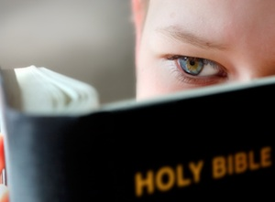**For**

Teen Family

**Season**

Fall

**Needed**

scissors, pencil, Know Your Bible Puzzle, Decoder Sheet

**Prepare in Advance**

You may want to cut out the squares of the puzzle ahead of time

**Activity Plan**

Describe the steps of the activity one by one in numbered fashion. Here is an example:

1. Say this prayer aloud to begin.

*God, thank you for giving us your Word. Be with us during this fun time of solving the puzzle and help us to learn more about your love for us in the Bible.*

1. Sometimes the Bible can feel like a puzzle, because it can be hard to understand things or even find what you are looking for. Share with each other: has there been a time when you have encountered something in the Bible that you didn’t understand?
2. Cut out each of the squares from the Get to Know Your Bible Puzzle.

Jesus was born

1. Work together to complete the puzzle by matching the two correct parts of the sentence. For example: If one square said, “Jesus was born” and another said “in Bethlehem” you would line up those to squares as shown so it completes the sentence correctly. Use the swirl pattern on the squares to check that they match up.

in Bethlehem

1. Now that you have the puzzle completed it’s time to decode the message. Do not take apart your puzzle yet, you’ll still need it together! On your decoder sheet you’ll see two rows of symbols. Find the square that has a matching symbol to the first symbol on the decoder sheet. If the puzzle is correct, there will be one word or phrase on that square that doesn’t have a match. Write that word under the symbol. Continue until you have figured out the whole code. Check Psalm 119:105 to see if you cracked the code!
2. As we get to know God’s word, we can see that God’s word is something that lights our path and helps us to know that God loves us. God’s word helps guide us in the right way to live; loving others and loving God. It can be fun to learn together about the Bible and begin to understand things that might be puzzling at first. How do you think God’s word can light your path? Are there ways that you as a family might get to know God’s word better?

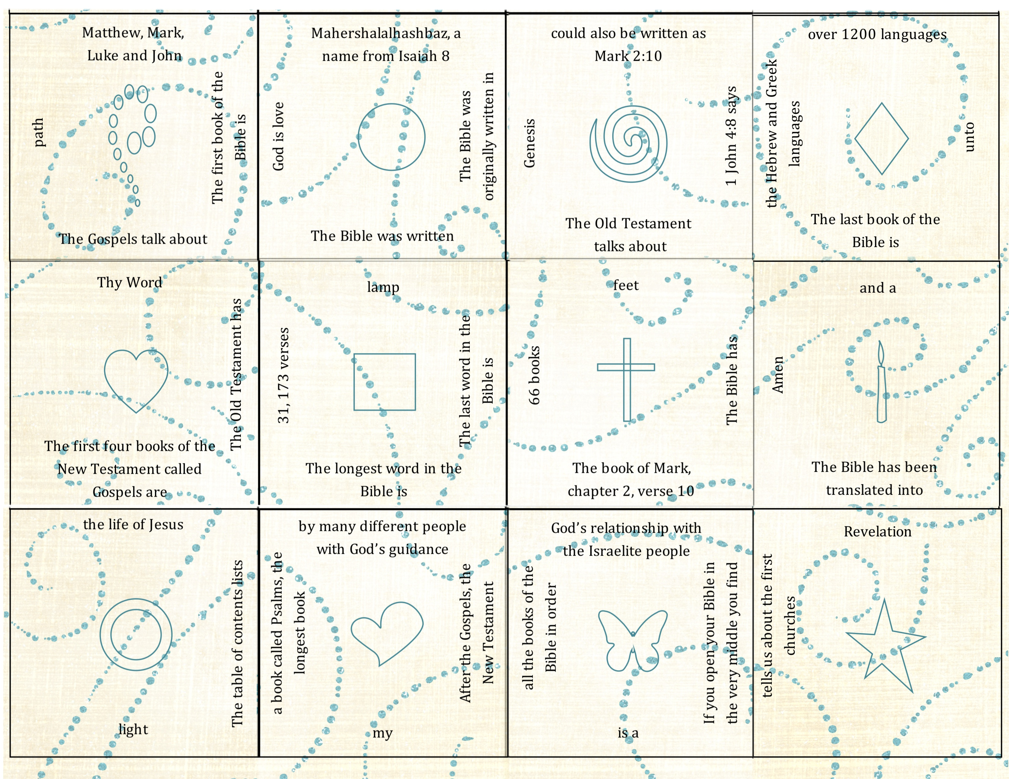

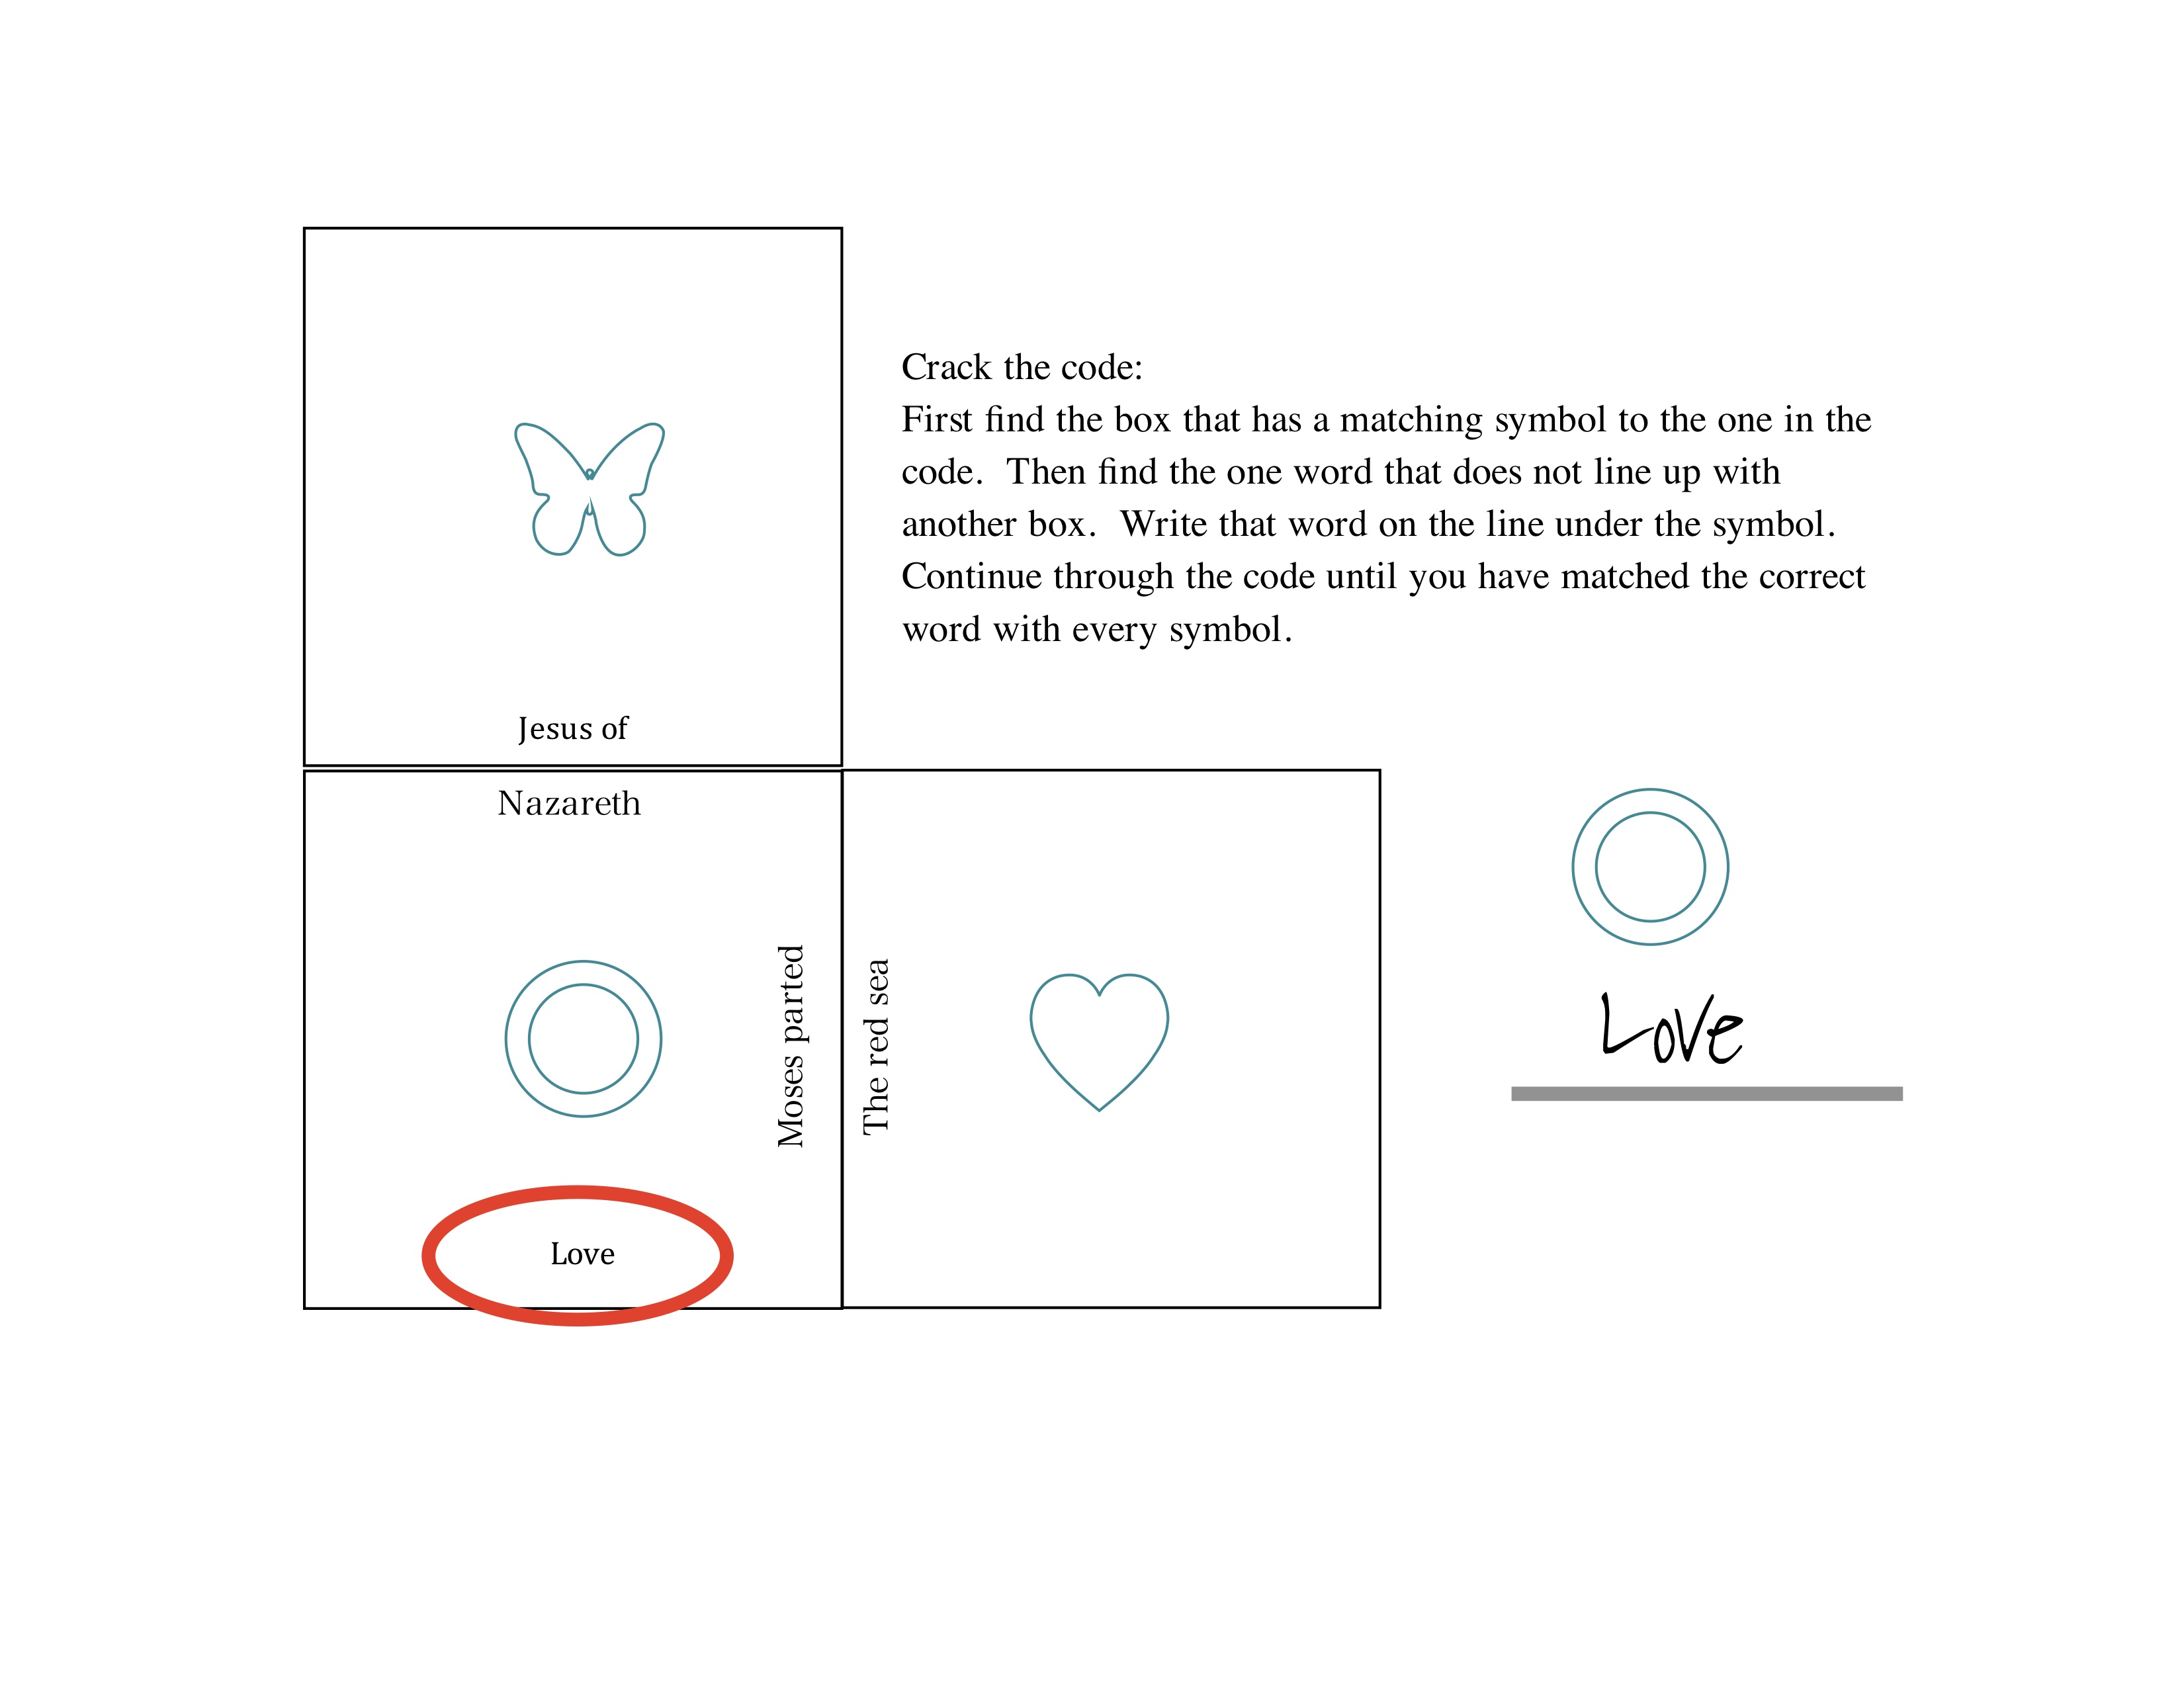



**Crack the Code!**

Follow this example:

Check Psalm 119:105 to see if you got it!

**Crack the Code:**

Follow this example:

**The Best Kind of Friend**

By Amber Espinosa

At this stop on your Bible trek, you’ll see that Jesus is a friend who never leaves anyone out. And, you’ll learn that Jesus is your friend too.

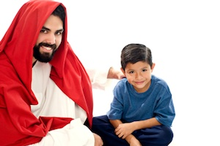

**For**

Just For Kids

**Season**

Fall

**Needed**

Markers or crayons, your Bible Trek book

**Prepare in Advance**

If you haven’t already created your Bible Trek book, go to Word Made Flesh, and find the directions for creating your own book. (Included at the end of this activity.)

**Activity Plan**

1. Read a story of Jesus eating dinner with unlikely people in Matthew 9:9-11:

“As Jesus passed on from there, he saw a man called Matthew sitting at the tax booth, and he said to him, ‘Follow me.’ And he rose and followed him. And as Jesus reclined at table in the house, behold, many tax collectors and sinners came and were reclining with Jesus and his disciples. And when the Pharisees saw this, they said to his disciples, ‘Why does your teacher eat with tax collectors and sinners?’"

1. Discuss

* In Jesus’ time, tax collectors were people who didn’t just collect taxes that were owed to the government. They also got rich by taking others’ money for themselves. People who were known as sinners were people who cheated others, or broke many of the religious laws. The religious leaders of the time saw these people as outcasts, people who shouldn’t be included in God’s love unless they changed their ways. But Jesus had dinner with them!
* What words would you use to describe Jesus in this story? What kind of person is he?
* Tell about some people who are left out by others at school.
* Tell about people in the world who get treated better or worse than others.

1. Read John 15:13 “Greater love has no one than this, that someone lay down his life for his friends.” Think of a way to remember Jesus’ love for you.
   * Who are your best friends? What are they like?
   * What does this verse tell us about the best kind of friend?
   * Jesus is the best kind of friend to us. Jesus came to be with us and to die with and for us because he loves us so much. Find a way to remember each day that Jesus loves you. You could…
     + Sing or listen to a song about Jesus every day. You might like these:

[Jesus Loves Me](mailto:http://www.youtube.com/watch%3Fv=-JOOMnWcIGQ)

[What a Friend We Have in Jesus](mailto:http://www.youtube.com/watch%3Fv=BTcQshpC8ZU)

* + - Make a cross craft and put it up somewhere in your house. There are lots of ideas if you do an internet search for “cross crafts for kids!”
    - Pick a favorite Bible verse and put it somewhere that you’ll read it every day.

1. Make a page of your Bible Trek: Jesus’ Life and Ministry book.

* Write the words, “Jesus is the best kind of friend.”
* Add a picture to help you remember what kind of friend Jesus is.

1. Pray this prayer as you finish this stop on your Bible Trek.

*Loving God, thank you for sending Jesus to be the best kind of friend to me. Help me to remember how much you love me. Amen*

**Word Made Flesh**

By Amber Espinosa

The Bible tells us that Jesus is God’s Word, made flesh. In other words, Jesus’ life and ministry are our best way of understanding God. Use these activities to learn what Jesus teaches us about God!

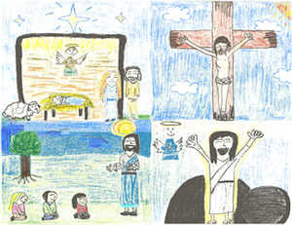**For**

Just For Kids

**Season**

Fall

**Needed**

8 sheets of paper or a small scrap book, crayons or markers, a stapler

**Prepare in Advance**

Staple 8 sheets of paper together to create a book, or use a small scrap book.

**Activity Plan**

1. Think about words.

* What’s a word? What do words do?
* If you could see and talk to God right now, what words would you say? What would God say?

2. Read John 1:1-2 and 1:14

“In the beginning was the Word, and the Word was with God, and the Word was God. He was in the beginning with God. All things were made through him . . . And the Word became flesh and dwelt among us.”

* Re-read the text and say “Jesus” instead of “The Word.”
* What does this text tell us about Jesus?

3. As you continue through Bible Trek: Jesus’ Life and Ministry, you’ll learn more about Jesus, and how His life teaches us about God. At each stop on the trek, you’ll create a page for a book to help you remember all that you’ve learned about God.

* Decorate the cover of your Bible Trek book. It might say, “Word Made Flesh” or “Jesus’ Life and Ministry.” Or, create your own title.

4. Pray:

*Loving God, Sometimes it’s hard to know what words are true about you, and which ones aren’t. Thank you for sending Jesus, your Word made flesh. As I learn about Jesus’ life, help me to know you more. Amen* .