+ Generations Together

Prayer Stations

Here is an intergenerational session for all members of the congregation exploring four different types of prayer by visiting four different prayer stations. This session is designed to be conducted in about 90 minutes, and can be adapted for a shorter or longer timeframe.

Introduction
Prayer goes better when you have something concrete to hold onto, or at least touch and feel—even if it’s your smartphone. In this session you’ll be exposed to objects that will help you pray and grow in your relationship with God: rock, altar, labyrinth, and as mentioned, smartphone. Visit as many of the prayer stations as you can!

Needed
Copies of the following activities:
Everybody Needs a Rock
Prayer Labyrinth
Social Media Prayers
Creating an Altar at Home

Read through each activity and collect the items needed for each activity, and gather enough of each for numerous families/small groups to engage in the activity simultaneously.

Prepare in Advance
- In your large gathering space, or in separate rooms, set up the four learning stations:
- Everybody Needs a Rock
- Prayer Labyrinth
- Social Media Prayers
- Creating an Altar at Home
- Create a sign for each learning station.
- Place all the necessary items in each learning station.
- Arrange to have one or two helpers at each station. These persons will assist families and small groups as they come through to do the station activity. The helpers should carefully read their assigned activity and make any necessary adaptations since the activity will not be done in a home setting for which it was originally intended.

I. Gather

Invite all participants to gather as one large group. Welcome them all and provide this introduction:

Prayer goes better when you have something concrete to hold onto, or at least touch and feel—even if it’s your smartphone. In this session you’ll be exposed to objects that will help you pray and grow in your relationship with God: rock, altar, labyrinth, and as mentioned, smartphone. Visit as many of the prayer stations as you can!

II. Stations

- Ask participants to form family groups or small groups of no more than 5-6 persons.

- Explain that each family/group will be invited to visit the prayer stations that you have set up, and engage in a particular prayer activity at each station. They will receive a printed copy of the prayer activity that they can take home with them. Tell them that each activity will take about 10-15 minutes to complete, and that there are helpers at each station. Encourage participants to respect the other groups as they engage in each activity by remaining relatively quiet throughout the process.

- Before sending people off to stations, have a helper from each station give a brief teaser/introduction to each activity:

- Everybody Needs a Rock: The Bible says that God is like many different things. God is like light and wind. God is like a mother hen and a loving shepherd and a great king. God is also like a rock. In this activity you will read some Bible verses that describe God as a rock. Then you’ll search for a special rock of your own.

- Prayer Labyrinth: Sometimes our bodies can move us into prayer when our mind has no clue where to go. This paper labyrinth can help focus our prayers when life is distracting.

- Social Media Prayers: Hundreds of ideas that suggest prayer needs are received from Facebook®, Twitter®, and texting each week. Remember your friend’s posting about her break-up? What about your cousin’s picture from his basketball game? How about that tweet that sounded like a call for help? Or maybe it’s a reminder of someone’s birthday! Try this helpful way to remember to pray for others at the end of each day.

- Creating an Altar at Home: In the Bible, Noah and his family and many animals were on a boat for a long time while God was making the world new. When Noah finally stepped off of that boat, he built an altar to say “thank you” to God. In this activity, you’ll hear Noah’s story, and learn how to make a simple altar in your home.

- Allow 45-60 minutes for families/groups to visit each station.

III. Go Forth

Conclude the session by following the adapted steps of the activity My (Lord’s) Prayer as follows.

Needed
Bible, bookmarks or slips of paper, My (Lord’s) Prayer worksheet (see page 4), pens or pencils

Prepare in Advance
Place bookmarks in your Bible at Matthew 6:9-14 and Luke 11:1-4. Make a copy of the My (Lord’s) Prayer worksheet for each person.

Activity Plan
- Ask participants to remain in their family/small groups.

- Read aloud Matthew 6:9-14 and Luke 11:1-4 from your Bible. Invite general comments about how these passages compare to the version of the Lord’s Prayer you are familiar with. Ask what are people’s favorite parts of the Lord’s Prayer, and perhaps any parts you wish you could change.

- Give each person a copy of the My (Lord’s) Prayer worksheet and a pen or pencil. Allow enough time for each person to complete the worksheet. Make sure no one feels rushed. Remind everyone that this is not “mad-libs,” and ask them to be serious about it.

- After everyone has finished the worksheet, ask family/group members to tell about what they wrote. Make sure not to judge anyone’s work.

- Conclude the session by asking all participants to stand, and on the word “Go” ask everyone to say her/his prayer out loud, simultaneously.

My (Lord’s) Prayer
By Lee Yates

Many Christians can recite the Lord’s Prayer from memory. This makes the prayer both special and easy to take for granted. What do the words mean? What are we really praying for when we pray these words? It is time to look at the words and make them our own.

For
Teen Family

Season
Summer

Needed
Bible, bookmarks or slips of paper, My (Lord’s) Prayer worksheet, pens or pencils

Prepare in Advance
Place bookmarks in your Bible at Matthew 6:9-14 and Luke 11:1-4. Make a copy of the My (Lord’s) Prayer worksheet for each family member.

Activity Plan
- Gather as a family and begin with prayer:
All-knowing God, bless us as we gather to explore your Word and pray. Amen.

- Ask a family member to read aloud Matthew 6:9-14 and Luke 11:1-4 from your Bible or from the text at the end of this activity. Compare these two Bible passages with the version of the Lord’s Prayer your family or your church uses most often. Discuss your favorite parts of the Lord’s Prayer and any parts you wish you could change.

- Give each person a copy of the My (Lord’s) Prayer handout and a pen or pencil. Allow enough time for each person to complete the worksheet. Make sure no one feels rushed. Remind everyone that this is not “mad-libs,” and ask them to be serious about it.

- After everyone has finished the worksheet, ask family members to tell about what they wrote. Make sure not to judge anyone’s work.

- Close by praying your family’s prayers. You can pray them all at the same time (don’t worry about the parts where the words don’t match) or one at a time.

Matthew 6:9-13
⁹ Pray then like this:
“Our Father in heaven,
hallowed be your name.
¹⁰ Your kingdom come,
your will be done,
on earth as it is in heaven.
¹¹ Give us this day our daily bread,
¹² and forgive us our debts,
as we also have forgiven our debtors.
¹³ And lead us not into temptation,
but deliver us from evil.
Luke 11:1-4
¹ Now Jesus was praying in a certain place, and when he finished, one of his disciples said to him, “Lord, teach us to pray, as John taught his disciples.” ² And he said to them, “When you pray, say:
“Father, hallowed be your name.
Your kingdom come.
³ Give us each day our daily bread,
⁴ and forgive us our sins,
for we ourselves forgive everyone who is indebted to us.
And lead us not into temptation.”

My (Lord’s) Prayer

- My favorite name for God:

- The place where I feel God’s presence most strongly:

- My favorite thing about God is:

My Prayer

O ___________, who is in________________, you are _______________.
(favorite name) (place) (favorite thing)

- I hope for __________________________________________.

- I need _____________________________________________.

- Forgive me for _______________________________________.

- Help me forgive others for ______________________________.

- Help me deal with ____________________________________.

- Protect me from ______________________________________.

God, you are all I need, now and always. Amen.

Everybody Needs a Rock
by Beth Beall

The Bible says that God is like many different things. God is like light and wind. God is like a mother hen and a loving shepherd and a great king. God is also like a rock. In this activity you will read some Bible verses that describe God as a rock. Then you’ll search for a special rock of your own.
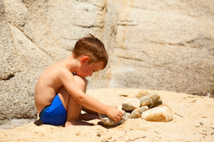
For
Just for Kids

Season
Summer

Needed
The Bible passage on the last page of this activity.
Optional: old crayons, a cookie sheet, an oven, and either old newspapers or an old towel. Optional: Everybody Needs a Rock, a book by Byrd Baylor. The book may be available at your local library.

Activity Plan
- Begin with a prayer. You might like to place your hands over your heart as you pray silently or aloud. If you’d like to use words, you could try these: “Loving God, you are strong like a rock. I can always lean against you. Thank you for taking care of me. Amen.”

- On your own or with an adult, read Psalm 18.

- After reading the Psalm, select one or more of these questions to think about or to discuss with someone else:
- Think of some of the rocks you’ve seen before. What are a few words you might use to describe those rocks? (For example, were they large, small, smooth, bumpy, multi-colored, oval-shaped, heart-shaped, egg-shaped?)
- I wonder how you think God might be like a rock?
- The Psalm says that God is like a steady rock under our feet. The Psalm also says that God is like a rock we can hide in. I wonder if you like one of those images more than the other: a steady rock under your feet, or a hiding place rock?

- Find some time to look for a special rock. Maybe there is a rock near your house. Or maybe you will be out walking someday, thinking about nothing at all, and suddenly you will see a rock that catches your eye. You might be surprised at all the places you start seeing rocks. Try to find one that you are allowed to keep, and bring it home with you.

- If your special rock is small, you might carry it in your pocket. If your rock is large, maybe you can find a place for it in your home. When you touch it, perhaps your heart will remember that God is like a rock.

Optional Activities

- Here is an art project you might like to do with a rock.
- Begin by washing any dirt off your rock.
- Then ask an adult to put the rock on a baking sheet and heat it in a 350-degree oven for 10-15 minutes.
- While the rock is heating, peel the paper off of some old crayons. Also place several layers of newspaper or an old towel on your workspace.
- The adult will remove the hot rock from the oven and place it on top of your newspaper or towel. IMPORTANT: THE ROCK WILL BE VERY HOT. DON’T TOUCH IT.
- Now comes the really fun part! Pick up a crayon and simply press it against the rock. Again, DO NOT TOUCH THE ROCK WITH YOUR BARE FINGERS. Let the crayon, not your fingers, touch the rock. As you press the crayon against the rock, it will melt like butter. Change the color of your crayon as often as you’d like.

- Next time you visit the public library, find out if there is a copy of a book called Everybody Needs a Rock, by Byrd Baylor. It is a story where a girl gives other kids ten rules for finding just the right rock. After all, everybody needs a rock!

Psalm 18
(selected verses)

I love you, God.
You are the one who makes me strong.
You are the steady rock under my feet.
You are the rock where I can hide when I am afraid.
Your way is straight and smooth.
You are a safe place for all who run to you.
You are the one true God.
You are a solid like a rock, and nothing compares to you.
I bless you, O God my rock.
Prayer Labyrinth
By Chip Borgstadt

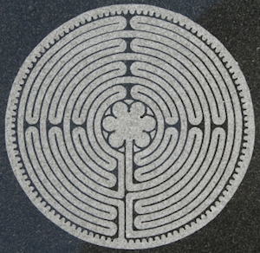
Sometimes our bodies can move us into prayer when our mind has no clue where to go. This paper labyrinth can help focus our prayers when life is distracting.

For
Adult / Couple

Season
Summer

Needed
Copy of paper labyrinth pattern, one for each person. Other labyrinth patterns can be found one using “spiritual labyrinth.”

Background
The labyrinth is an ancient practice that has been adopted by Christians centuries ago. A labyrinth, unlike a maze which has dead ends in the paths, has a single path that goes to the center and leads the person back to the entrance. Larger walking labyrinths allow a person to trust the path and permit the mind to bring forth important concerns or affirmations. A paper labyrinth is followed with one’s finger or a pointer (you may use a retractable ballpoint pen with the pen retracted.) It can have the same effect as a walking labyrinth. You can do this prayer exercise in solitude or with others.

Activity Plan
- Find a quiet place free from distractions. Read Romans 8:26-27 aloud from your Bible or from the text here:
Likewise the Spirit helps us in our weakness. For we do not know what to pray for as we ought, but the Spirit himself intercedes for us with groanings too deep for words. And he who searches hearts knows what is the mind of the Spirit, because the Spirit intercedes for the saints according to the will of God.
- Take several deep breaths and relax. Place your finger or pointer at the entrance to the paper labyrinth and say a prayer. You might say something like:
Eternal God, you guide us through your Spirit. Move through me this day. Open my spirit to understand your work in my life at this time. Amen.
- Move through the labyrinth slowly and deliberately. As a thought comes to mind, receive it and allow it to form. Reflect on that thought. You might consider relationships or situations that it suggests. Invite the Spirit to add to the thought. If you can form a prayer around it, do so.
- When you reach the center of the labyrinth, hold your finger or pointer still. Silently name the thoughts you have had entering the labyrinth.
- As you move out of the labyrinth by tracing the route in reverse, allow your spirit to receive new thoughts or reflect on those raised so far. When you get to the exit, pause. If you want to pray, you may do so.
- Write a few words about your experience in the labyrinth on the margins of the page. Prayer concerns that you might not be aware of can be surfaced and developed in the coming days.
- If you are doing this activity with others, take a moment when all are done to share something that you experienced or reflected upon while moving through the labyrinth.
- The labyrinth can be done many times during the day. It can help you focus your spirit and thoughts. Moving through the labyrinth daily for a week can be quite beneficial.

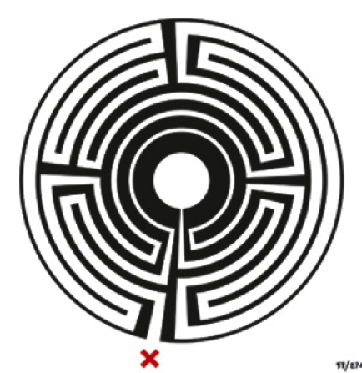

Social Media Prayers
By Audrey Cox

Hundreds of ideas that suggest prayer needs are received from Facebook®, Twitter®, and texting each week. Remember your friend’s posting about her break-up? What about your cousin’s picture from his basketball game? How about that tweet that sounded like a call for help? Or maybe it’s a reminder of someone’s birthday! Try this helpful way to remember to pray for others at the end of each day.

For
Teen Family

Season
Summer

Needed
Computer or cell phone, Prayer Reminder worksheet, scissors

Prepare in Advance
Make a copy of the verse on the Prayer Reminder worksheet for each person.

Activity Plan
- Gather as a family and begin with prayer:
Thank you, God, for always being ready to hear us when we come to you in prayer. Amen.

- Give each person a copy of the Bible passage from the Prayer Reminder worksheet to place somewhere near his or her bed, perhaps on a nightstand or headboard. Read it in unison and discuss what these instructions might mean for Christians today.

- Spend a moment recalling the messages family members have received in the past day via Facebook®, Twitter®, or texting. Which of these messages suggest a person or a family in need of prayer?

- Discuss how family members can keep track of prayer needs they see throughout the day as they use social media. For example, you might keep track in a text message to yourself, on an application for notes, or in a computer document. Challenge one another to gather four or five notes about prayer needs each day.

- Before you go to bed, read the verse from Timothy as a reminder to pray for all people. Take a few minutes to pull up your notes from the day and pray for the individuals you listed. Here are some examples:
  - Someone posts about working on homework late at night—pray that God will give him or her wisdom and strength to finish the assignment.
  - You read a Twitter® conversation that seems pretty negative—pray for quick and peaceful resolution to the conflict.
  - Someone posts a photo of a recent accomplishment—give thanks to God for his or her success.
  - It’s a friend’s birthday—praise God for the life of this individual.

- Once a week, perhaps at mealtime, take time as a family to talk about the prayer needs you’ve noted in the past few days.
Prayer Reminder

First of all, then, I urge that supplications, prayers, intercessions, and thanksgivings be made for all people, for kings and all who are in high positions,
that we may lead a peaceful and quiet life, godly
and dignified in every way. This is good, and it is pleasing in the sight of God our Savior.

– 1 Timothy 2:1-3

First of all, then, I urge that supplications, prayers, intercessions, and thanksgivings be made for all people, for kings and all who are in high positions,
that we may lead a peaceful and quiet life, godly
and dignified in every way. This is good, and it is pleasing in the sight of God our Savior.

– 1 Timothy 2:1-3

Creating an Altar at Home
by Beth Beall

In the Bible, Noah and his family and many animals were on a boat for a long time while God was making the world new. When Noah finally stepped off of that boat, he built an altar to say “thank you” to God. In this activity, you’ll hear Noah’s story, and learn how to make a simple altar in your home.

For
Just for Kids

Season
Summer

Needed
The Bible story on the last page of this activity.
Any materials (found or created) that symbolize your thankfulness to God.

Activity Plan
- Begin with a prayer. You might like to place your hands over your heart as you pray silently or aloud. If you’d like to use words, you could try these: “Loving God, you hold me in your heart. I am safe in your love. I give you my thanks. Amen.”

- On your own or with an adult, read the Bible story on the last page of this activity.

- When Noah and the others finally got off the ark, Noah wanted to say “thank you” to God. I wonder if there’s something that has happened to you or your family that makes you want to say “thank you” to God?

- Instead of only saying “thank you” with his words, Noah built something called an altar to show his thanks. Noah’s altar was probably a collection of rocks, with a space for a fire on top. You and your family can create an altar, but one without fire! An altar can be any place in your home that you turn into a special place for God. Here are some ideas for creating an altar at home:

- Find a place that feels special to you. Perhaps there’s an empty space on a bookshelf. Or perhaps the middle of a table could become your altar. If you want the altar to be just for you rather than for your entire family, maybe you could find a spot in your bedroom.

- Begin by putting one or two symbols of thanks to God on your altar. For example:
- Did you have a great time playing soccer today? You could draw a picture of your game or draw a picture of a soccer ball. Then place your drawing on the altar.

- Did you find a special rock when you were out walking with a friend? Put the rock on your altar and thank God for the amazing world we live in.
- Did someone send you a wonderful card on your birthday? You might want to add the card to the altar, too, as you thank God for the people who love you.

- Add items to the altar or remove them as you would like. The important thing about your altar is that it reminds you of why you want to give thanks to God. You may add more items to the altar whenever you like. You may also remove items when that feels like the right thing to do. Maybe you’ll want to keep your altar assembled for a few days, a few weeks, or longer. And when you are ready to take the altar apart altogether, that’s OK, too.

Example
Here is a picture of the altar that I have in my home right now. You can see that I created my altar in a wide windowsill. The piece of driftwood reminds me of a wonderful vacation at the beach. The feathers remind me to thank God for the beautiful birds that fly near my house. The beaded object is a gift from a young friend, and it reminds me of her. The statue reminds me of Jesus. And the bowl of water reminds me to thank God for the gift of clean water.

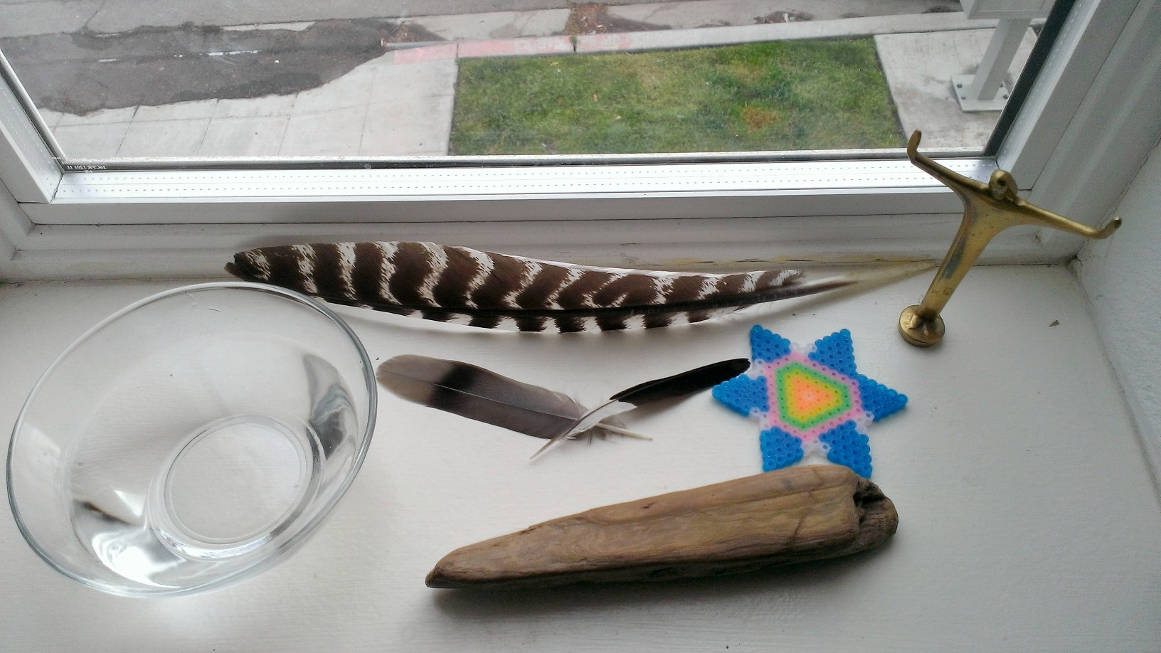

photo by Beth Beall, April 2013

A Re-telling of the Story of Noah
(Genesis 6:5-9:17)

A long, long time ago, God looked with sadness upon the world. People were not living as God wanted, and the world was falling apart. So God decided to make the world brand new. There was one man, Noah, who walked in God’s ways. God told Noah to build a very large boat called an ark. Noah took his entire family and lots of animals onto the ark. Once Noah, his family and the animals were safely inside, God opened the heavens and the rain began to fall, and fall, and fall. The rain washed away the rest of the world.

The rain lasted a long, long time. Rain fell for forty days and forty nights. Even after the rain stopped, Noah and his family and all the animals had to stay on the ark because the world was still covered in water.

After almost a year, dry land emerged. Noah and his family and the animals came out of the ark and looked upon the beautiful new world that God had created. Noah built a special fire called an altar to say “thank you” to God. God looked upon the altar and was pleased. Then God blessed Noah and his family, and the animals. Finally, God put a rainbow in the sky as a sign of his faithful love to the new creation.

