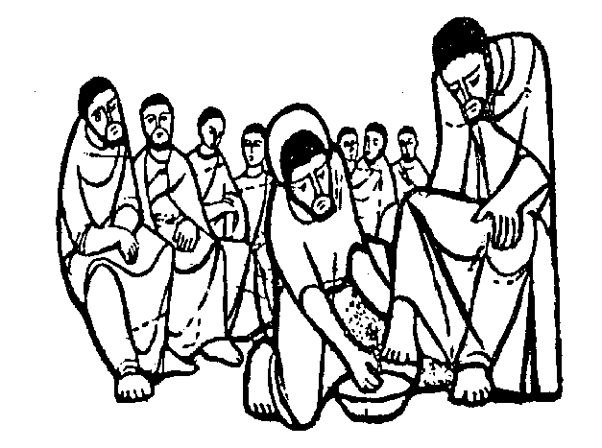
PRAYER FOR
INSTRUMENTS OF GOD’S MERCY

INTRODUCTORY RITE

The celebrant says:

In the name of the Father, and of the Son, and of the Holy Spirit.

All make the sign of the cross and reply:

Amen.

PRAYER

The celebrant prays.

Let us pray.

O my God, we love you above all things
Because you are all good and worthy of our love.
We love our neighbors as ourselves for the love of you.
We forgive all who have injured us and
Ask pardon of all whom we have injured.

We pray through Christ our Lord.

All reply

Amen.

READING OF THE WORD OF GOD
First Corinthians 12: 14-26

A reader or the celebrant reads a text of sacred Scripture.

A Reading from the First Letter of St. Paul to the Corinthians.
Now the body is not a single part, but many. If a foot should say, “Because I am not a hand I do not belong to the body,” it does not for this reason belong any less to the body. Or if an ear should say, “Because I am not an eye I do not belong to the body,” it does not for this reason belong any less to the body.
If the whole body were an eye, where would the hearing be? If the whole body were hearing, where would the sense of smell be? But as it is, God placed the parts, each one of them, in the body as he intended. If they were all one part, where would the body be? But as it is, there are many parts, yet one body. The eye cannot say to the hand, “I do not need you,” nor again the head to the feet, “I do not need you.” Indeed, the parts of the body that seem to be weaker are all the more necessary, and those parts of the body that we consider less honorable we surround with greater honor, and our less presentable parts are treated with greater propriety, whereas our more presentable parts do not need this. But God has so constructed the body as to give greater honor to a part that is without it, so that there may be no division in the body, but that the parts may have the same concern for one another. If [one] part suffers, all the parts suffer with it; if one part is honored, all the parts share its joy.
The Word of the Lord.
All reply.

Thanks be to God.

VIDEO REFLECTION

All view the video.

Works of Mercy: https://www.youtube.com/watch?v=gR_-_TOhRtg

All pray together (from the PowerPoint slide).

Christ Has No Body: Prayer of St. Theresa of Avila

Christ has no body now but ours.
No hands, no feet on earth but ours.
Ours are the eyes through which He looks compassion on this world.
Ours are the feet with which He walks to do good.
Ours are the hands with which He blesses all the world.
Ours are the hands.
Ours are the feet.
Ours are the eyes.
We are His body.
Christ has no body now on earth but ours.

Adapted from https://young-catholics.com/2017/12/09/christ-has-no-body-st-teresa-of-avila/
Prayer card: https://young-catholics.com/wp-content/uploads/2017/12/Christ-Has-No-Body.pdfPRAYER

PRAYER

The celebrant prays.

Let us pray.

God of Mercy,
As you have forgiven us
You send us forth
To offer merciful care to our neighbors.

Give us willing feet and gentle hands.
Bless us with listening ears and searching eyes.
Endow us with understanding minds.
Ordain us with compassionate hearts.

In our acts and in our words
Make us vessels of your mercy
To reach out to the broken
On behalf of the father who wipes away our debts
As lovingly as he wipes away our tears
And calls his children home.

Help us lift your people in body and spirit.
And make ours a parish of mercy.

We ask this through Christ our Lord.

All reply

Amen.

Adapted from Vessels of Mercy: https://www.crs.org/resource-center/vessels-mercy

BLESSING

The celebrant continues with the prayer of blessing.

May Almighty God bless us,
In the name of the Father, Son, and Holy Spirit.

All make the sign of the cross and reply:

R. Amen.

