Finding Faith in Harry Potter September 28-29, 2018
4:30pm Arrive, bring stuff up to rooms, enter parish hall through “brick wall” of train station, have games, word searches, would you rather game, coloring
Mike will take their pictures
5pm Welcome by Professor McGanagall= Mindy, introductions and rules of Hogwarts
5:15pm Clip of Harry being called by Hagrid- Sue
Raise questions: How does Harry find out that he’s a wizard? (Hagrid comes to the place where he is staying to tell him) How does he react to the news? (He is amazed) Why doesn’t he think he can be a wizard? (Harry doesn’t think he is anything special)
Sorting/welcome to Hogwarts video clip- Sue
Explain that all 4 houses have good qualities, and to make the house your own- Mindy
5:30pm Go up to church by altar, sorting hat activity (Mindy)
- Sorting hat chooses you; marks you for a certain house
- Just like baptism, you are marked as God’s own and a member of God’s house forever
- Called by name; connection with baptism and receiving a Hogwarts letter
- Who am I? 1 “as we saw in the video clip when Harry finds out who he is… in our baptism we find out who we are; children of God, beloved child of God

- (Direct them down to the Great Hall where they will sit with their house for the feast)

- 6:00pm Feast in parish hall- served at long tables, family style, chicken, mashed potatoes, sides, rolls, dessert, Table grace before meal, Loving God, Thank you for bringing us here to be together. Thank you for making each of us unique and calling us to be your children. Help us to remember that in all that we do. Bless this food we are about to eat, and bless those who go without this night. We ask this in Jesus’ name. Amen.
(Sue will show the 30 second clip of Dumbledore saying “let the feast begin!”)
6:30pm Wand making – Mindy will talk about wands
- wands give the holder of it power, could be used for good or evil; that depends on the holder of the wand (think Harry vs Voldemort)
-What are the wands in our lives? Smart phones (social media), credit and debit cards, guns, voter ID cards- they each have power that can be used for good or evil

COUNT OFF INTO GROUPS OF 3 and DISCUSS;

- If you had a magic wand what would your life be like?
- If you had a magic wand, what one problem would you change in the world?
- If you could wave a magic wand and create anything in your life, what would It be?
- If you had a magic wand and could experience anything at all in your life, what would it be? (money is not an issue)

Make Wands -(Ascension-Syndie) in children’s room
- Write names on paper placemat and put wand there to dry
I’ll have everything set up in the lower level children’s room (which will be named a Hogwarts classroom). There will be a variety of chopsticks, acrylic paints, glitter, glue sticks and glue guns, beads, etc.
- Warm up the glue guns/
- Have them paint their chopstick whatever color they want
- Then they start wrapping the hot glue around it to make it 3D, then they paint over the dried glue with contrasting color

7:00pm Scavenger Hunt- gather in hall for directions(Sue) (I’ll have it ready) , need adults at certain spots- will end up in church by baptismal font with last clue, have adult to have direct them back to hall
7:45pm Sit in house groups in hall- talk by senior high/Mindy about choices “It is not our abilities that show what we truly are; it is our choices.” Dumbledore
Show clip- HP And Chamber of Secrets clip 2:12:27-2:15:36 Talk- love, respect and sacrifice for others, Harry’s mom sacrificed for him, Ron sacrificed in the chess game for Harry and Hermione, Sirius, Dumbledore died for others, Harry chose death to save others; we don’t have to choose between life and death, but we do have many choices in life that affect others.
- Right and wrong situations activity; do in small groups
8:10pm Classes – Potions- (Dave and Mike) separate materials- set up in children’s room
8:40pm Snacks/Free Time/Visit HoneyDukes-Sue
9:10pm Defense of Dark Arts (St. Mary’s -LeeAnne) in hall, Dementors in our Lives, Our Personal Patronus, Making Patronus Charm Keychain
Defense Against the Dark Arts Class
Talk about the dementors in our lives- pages 11-13, 65-68, 153-155 of Tricia’s Book)
-have them write words on post it notes & put them onto the black posterboard hanging in the room.
-then move to what are the Patronus Charms in our lives… who are the people; the images, the stories, the inspiration we can call upon when dementors try to enter our lives and suck the happiness from it
- watch video clip of all the patronuses in the movies… https://youtu.be/vwwiMCtviZM
-then have all of them come up with their Patronus charm keychain they can carry with them; keep on their backpack or with their keys. It will be made up of: 1. a keychain with a washer on it that they will stamp with a word or two the will remind them of the power within them to defend themselves against the dark (love, Jesus, hope, etc… we will have suggestions and examples) 2. Charms- they will select one animal charm ( I have sheets that describe various animal patronuses and what they mean), one lightning bolt, one heart (there are two kinds) and one cross (there are two kinds); and then attach them with jump rings to their keychain. Wrap up with God/Jesus being the light in our lives; the Patronus that will always be with us…
10pm Go up into church, walk down darkened side aisle, to forest at the back of church, where there will be candles; each person gets a candle and walks up the main aisle lit with aisle candles to the baptismal font for brief Night Prayer; focusing on light.

10:15pm up to sleeping rooms
10:30pm lights out
Saturday
8:30am Breakfast- (Sue and Kathleen) in Great Hall, sit with House
9:00am talk- What do we seek?, seeker, p48 Tricia’s book (Mindy/LeeAnne)
9:30am Quidditch outside159-162 (Sue will explain rules 2 houses play at a time, other 2 houses sit and watch and cheer, I have pinnies instead of headbands for teams)

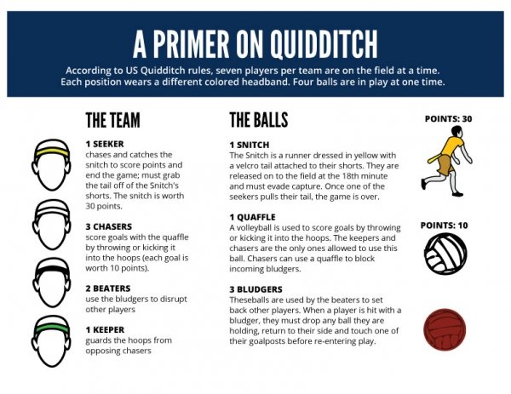

Rules
Quidditch is a mixed gender contact sport with a unique mix of elements from rugby, dodgeball, and tag. A quidditch team is made up of seven athletes who play with brooms between their legs at all times. While the game can appear chaotic to the casual observer, once familiar with the basic rules, quidditch is an exciting sport to watch and even more exciting to play.
Three chasers score goals worth 10 points each with a volleyball called the quaffle. They advance the ball down the field by running with it, passing it to teammates, or kicking it. Each team has a keeper who defends the goal hoops. Two beaters use dodgeballs called bludgers to disrupt the flow of the game by “knocking out” other players. Any player hit by a bludger is out of play until they touch their own goals. Each team also has a seeker who tries to catch the snitch. The snitch is a ball attached to the waistband of the snitch runner, a neutral athlete in a yellow uniform who uses any means to avoid capture. The snitch is worth 30 points and its capture ends the game. If the score is tied after the snitch catch, the game proceeds into overtime.
During play, players are forbidden from taking certain actions, or fouls. Players who commit fouls face different consequences depending on the severity of the offense. A back to hoops foul indicates that a player must stop and return to their hoops, as though knocked out. A yellow card indicates that a player must spend one minute in the penalty box. A red card indicates that a player is barred from the rest of the game.

PHYSICAL CONTACT In this adaptation, there should be no physical contact of any kind. Players (chasers, beaters, and keepers) may attempt to steal a ball (quaffle or bludger) from another player, but they may only touch the ball they are attempting to steal, not the player carrying the ball. Seekers and snitch runners should also avoid physical contact, including grappling that is permitted in the full rules. Physical contact as described in section 6.3 should not be permitted for this age group: middle school players may not stiff arm, push, charge, grab, wrap, or tackle another player.

10:30am Gather in hall for beverages and quick break
10:45am the Mirror of Erised activity -p78-81- “It does not do to dwell on dreams, and forget to live.” what Mirror is for us as Christians – (Mindy) Sue will have video clip of Harry, Dumbledore and the mirror to start out, will need an adult for activity to keep kids in order on sheet so Mindy knows who is coming in…After talk, They will fill out activity sheet and while doing that, go one at a time into coat room for transparency mirror activity with Professor Mindy- they will go into room with mirror made from scrim sheet on a large frame; overhead projector will be turned on with their face projected onto mirror from the picture we took the night before; Mindy uses script and tells them to close their eyes; she layers the transparency sheet of Jesus extending his hand onto their picture, then they open their eyes to see it. Professor McGonagall guides participants to the Mirror of Erised. Each participant first sees himself as a Hogwarts student, Professor tells him/her they have been transformed by God's grace and that Quirrell and Voldemort couldn't touch him/her or hurt him/her because he/she was protected by a love so strong, powerful and complete it was willing to give its life for him/her.
McGonagall tells each participant to look at himself/herself again to see his/her transformed self. Student now sees themselves with Jesus' arm around him/her. McGonagall tells them to reach into the mirror and take the stone of life everlasting with God. She says, “Well done,” and invites them to the feast. During this time, some of the “professors” are in the passageway guiding participants in and out of the Great Hall
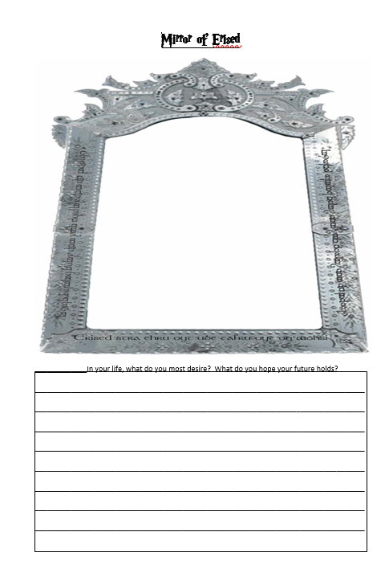
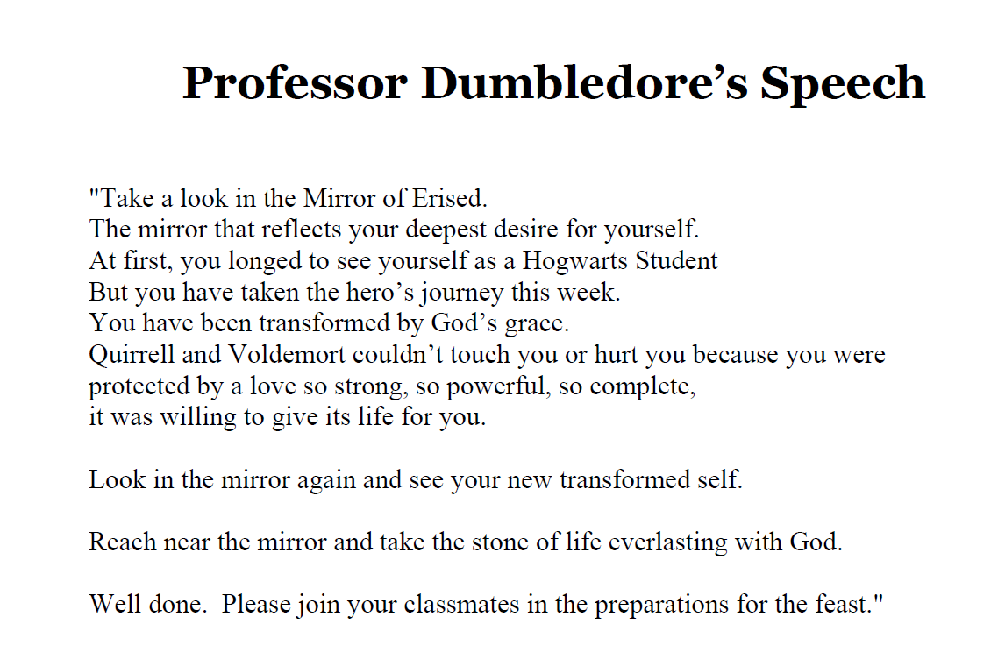
11:00am Free Time, have HP games, metal stamping activity, - have round tables set up
11:30 Lunch
12:00pm Triwizard Tournament (Sue explain)
The Tri-Wizard Tournament consisted of 1) getting the egg from the dragon, 2) retrieving a loved one from the lake and 3) finding the Tri-Wizard Cup in a maze.
Dragon Egg
We designated an area where we placed a large plastic egg. One of the staff put on a dragon hat and a tail as he was the dragon. One person from each house took turns attempting to get the egg from the dragon. If after one minute the student was unable to get the egg a second student then helped. Now it was two students against the dragon. The participants with the fastest time received house points. (could play it like capture the flag too)

THEN EACH FIND A DRAGON EGG

Retrieving a Loved One
Blindfold one student from each house and place an object (will use gold trophy cups) about 20 yards away in a large open field. The other students, the “callers”, from their house then had to verbally lead the blindfolded student to the owl. The “callers” had to stay where they were. In other words they could not walk with the blindfolded student. The blindfolded students, one from each house, all go at the same time. What happens is that “callers” are yelling instructions and the blindfolded students have a hard time figuring out which instructions they should follow. It’s a really fun team building exercise usually called Blind Fetch. Points were awarded for the quickest participants.
Tri-Wizard CupThe cup is a large plastic trophy that we hide somewhere outside. All the students scatter to try and find it. (prize for one who finds it)
1:30pm Back into the Great Hall for beverages and quick break; then show the church as the room of requirement video clip- Mindy talk about church as room of requirement

1:45pm Power of Love – Harry Potter Alliance (Sue, Mindy, LeeAnne) (have basket with Free Dobby Sock collection) “The weapon we have is love”, what can we do in the world to fight evil? P13, 169=the ultimate resistance to evil and injustice is love. LeeAnne talk about her efforts to fight evil
Sue talk about Harry Potter Alliance, others wrap up with what are each of us called to do to fight evil in the world with love?
Service Project- make kits for Community Connection event- the one stop event at Damniano Center that provides a broad range of free services for those experiencing homelessness or at risk of homelessness.

2:30pm Closing in Church- Resurrection talk (Mindy/LeeAnne/Bill) – “Despite Harry’s brokenness, he chooses to follow love to the moment when he can kiss the snitch and say, “I am about to die.”
LeeAnne/Bill? Communion Pass out loaf of bread; harry was broken but believed in resurrection; we break bread as we say,
“dying you destroyed our death, rising you restored our life, Lord Jesus, come in glory.”

The Confrontation with Evil- up in church around baptismal font
Everyone stands for the final confrontation with evil; confronting Voldemort.
Voldmort makes six statements and everyone responds from the Baptismal Covenant
Voldemort asks the following:
1. Come join me and I will make you a powerful wizard.
Bill: Do you renounce Satan and all the spiritual forces of wickedness that rebel against God?
All: I renounce them.
2. Come where the real power is, on the dark side.
Bill: Do you renounce the evil powers of this world, which corrupt and destroy the creatures of God?
All: I renounce them.
3. I can give you powers to satisfy your every wish.
Bill: Do you renounce all sinful desires that draw you from the Love of God?
All: I renounce them.
4. You are mine, I made my mark on you with that lightning bolt.
Bill: Do you turn to Jesus Christ as your Savior?
All: I will turn to Christ.
5. Don't be a fool, join me, only I can save you.
Bill: Do you put your whole trust in Jesus' Grace and Love?
All: I put my trust in Jesus.
6. I can make you immortal if you just give me the stone.
Bill: Are you going to promise to follow Jesus?
All: I will follow Jesus....

Bill knocks over the dementor

Closing Blessing

