THANKSGIVING TURKEY HAND PRAYER
Introduction
Have you ever used your hand to draw a Turkey?
Leader demonstrates by tracing with one hand the thumb and fingers of the other hand.

Imagine your hand is a Turkey. You are going to use your Turkey hand to pray.

With your thumb and each finger, you will thank God for one of your many blessings: family, friends, teachers, doctors and nurses, yourself
Leader demonstrates by wiggling one at a time the thumb and fingers of one hand for each blessing.

Thanksgiving Turkey Hand Prayer
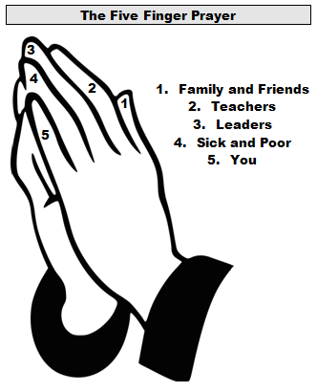
I thank God for …
- My family and friends who care for me.
- My teachers who help me learn.
- My pastor who prays for me.
- My caregivers who help me when I am sick.
- Me, a child of God.
Amen.
Blessing of Hands
Now we bless our hands to be a blessing for others.
All raise hands over their heads.

O God/bless our hands/as a blessing for others.
Leader prays each syllable of the blessing prayer. All repeat each syllable

Amen.

Song: Now Thank We All Our God (Ritual Song #700)

