SAINT JOSEPH FEAST DAY
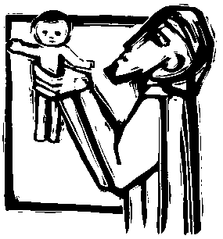

Introduction
LEADER
We remember Saint Joseph, Patron of our parish. He was the good man who made a home for Jesus and for his mother, Mary.

Prayer
LEADER
Almighty God, in your wisdom and love
You chose Joseph to be the husband of Mary,
The mother of your Son.
As Jesus relied on his protection on earth
May we have the help of his prayers in heaven.
We ask this through Christ our Lord.

ALL
Amen.

Leader explains the Litany responses and describes the procession route. Music minister plays instrumental music during the procession.

Litany of Saint Joseph
LEADER
Let us pray the Litany of Saint Joseph in procession around the Church.
LEADER ALL
Lord, have mercy. Lord, have mercy.
Christ, have mercy. Christ, have mercy.
Lord, have mercy. Lord, have mercy
Good Saint Joseph … Pray for us.
Descendant of the House of David … Pray for us.
Husband of Mary … Pray for us.
Foster father of Jesus … Pray for us.
Guardian of Christ … Pray for us.
Support of the Holy Family … Pray for us.
Model of workers … Pray for us.
Example to parents … Pray for us.
Companion of the poor … Pray for us.
Protector of the Church … Pray for us.
LEADER
Merciful God,
Grant that we may learn from St. Joseph
To care for the members of our families and
Share what we have with the poor.
We ask this through Christ our Lord.

ALL
Amen
Our Father
LEADER
Let us pray with the words that Jesus taught us.
ALL
Our Father …
Song: A Living Faith (Ritual Song #726 vv. 1-2)

