GROWING FAMILIES 2018-2019
Session Two
Called to be Followers of Christ
Beginning Prayer

LITANY OF THE SAINTS

LEADER:
God knows all the Baptized by name. God loves us all. God’s love makes us holy. God’s love makes us saints. On All Saints Day we honor all God’s holy men and women, those who have died and those who are living. We are living Saints.

LEADER:
The Litany of Saints is an ancient Catholic prayer to honor all God’s holy people. We are called to be saints too. We will add to the Litany some of our first names, our Baptismal names.

LEADER:
- Describes the Litany of Saints Handout
- Asks two Confirmation Candidates to the front of the altar to demonstrate the prayer
- Invites ten volunteers to the front of the altar to add their names to the prayer
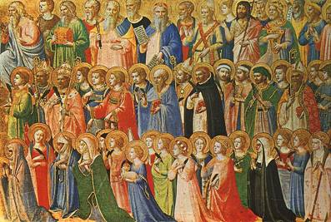
GROWING FAMILIES

LITANY OF THE SAINTS*

Leader:
In honor of all God’s holy people, let us pray a litany of saints, asking for the help of Mary, the saints and all great witnesses to Jesus.

Cantor: All Sing Together:
Lord have mercy. Lord, have mercy.
Christ, have mercy. Christ have mercy.
Lord, have mercy. Lord, have mercy.
Holy Mary, Mother of God… pray for us.
Saint Michael… pray for us.
All you holy angels and archangels… pray for us.
St. John the Baptist… pray for us.
St. Joseph… pray for us.
All you holy patriarchs and prophets… pray for us.
Saint Peter and Saint Paul… pray for us.
Saint John… pray for us.
All you holy apostles and evangelists… pray for us.
All you holy disciples of the Lord… pray for us.
Saint Stephen… pray for us.
All you holy martyrs… pray for us.
Saint Benedict… pray for us.
Saint Francis… pray for us.
Saint Teresa… pray for us.
Saint Catherine… pray for us.

Volunteers Add their Names:
Saint ________… pray for us.

Cantor:
All holy men and women… pray for us.

All Pray Together:
Loving God, we are surrounded by holy people. With them we pray through Christ our Lord.
Amen.

*All Saints Day, November 1, 2018

