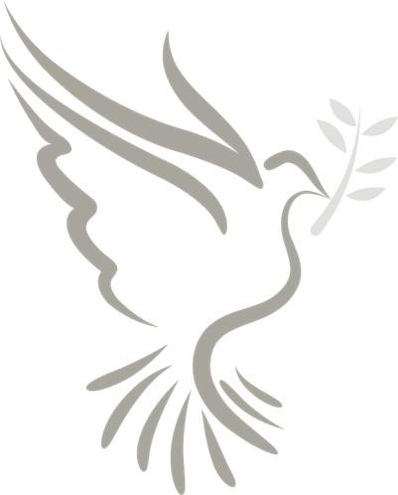
NEW YEAR
PRAYER FOR PEACE

Introduction
Catholics celebrate World Day of Peace on the first day of the new year. This year in his World Day of Peace Message, Pope Francis wished everyone “a life filled with joy and hope”.
https://www.vaticannews.va/en/pope/news/2020-01/hope-at-heart-of-pope-francis-peace-day-messages.html

Prayer
L: Let us pray.

God of peace, you created us and you call us to live as brothers and
sisters.

Give us the strength daily to be instruments of peace; enable us to
see everyone who crosses our path as our brother and sister.

Help us turn our instruments of war into implements of peace, our
fear into confident trust, and our quarreling into forgiveness.

We ask this through our Lord, Jesus Christ.
R: Amen
Adapted from Pope Francis’ Prayer for Peace http://www.usccb.org/prayer-and-worship/prayers-and-devotions/prayers/pope-francis-prayer-for-peace.cfm
Beatitudes

L: A reading from the Gospel of Matthew.
Blessed are the peacemakers, for they shall be called the sons and
daughters of God.

You have learned how it was said, “You must love your neighbor
and hate your enemy,” but I say to you, “Love your enemies, and
pray for those who persecute you”.

In this way, you will be daughters and sons of your Creator in
heaven.

L: The Gospel of the Lord.
R: Praise to you Lord, Jesus Christ.

Prayer for World Peace

L: + We give glory to God—the Father, Son, and Holy Spirit.
1: Let the earth be filled with peace.

R: God, bring us peace.
2: Let justice and mercy come upon every nation on earth.

R: God, bring us peace.
3: Let our families live in peace and grow in love.
R: God, bring us peace.
4: Let those in military service return home safely.

R: God, bring us peace.

L: God, our Father, help us to work for the justice which brings true
peace.

We ask this through Jesus Christ, our Lord.

R: Amen.

Adapted from the PCUSA Vow of Nonviolence based on Liturgy of the Hours, Week 1, Sunday Evening Prayer https://paxchristiusa.org/resources/vow-of-nonviolence/

Family Pledge of Nonviolence
L: Making peace must start within ourselves and in our families.
We commit ourselves as best we can to become peacemakers.
Participants raise their right hands and make the Peace symbol with their fingers

To respect myself, to affirm others and to avoid uncaring criticism,
hateful words, physical attacks and self-destructive behavior.

R: I do.

L: To share my feelings honestly, to look for safe ways to express my
anger, and to work at solving problems peacefully.

R: I do.

L: To listen carefully to one another, especially those who disagree
with me, and to consider others' feelings and needs rather than
insist on having my own way.

R: I do.

L: To apologize and make amends when I have hurt another,
to forgive others, and to keep from holding grudges.

R: I do.

L: To treat the environment and all living things, including our pets,
with respect and care.

R: I do.

L: To select entertainment and toys that support our family's values
and to avoid entertainment that makes violence look exciting, funny
or acceptable.

R: I do.

L: To challenge violence in all its forms whenever I encounter it,
whether at home, at school, at work, or in the community, and to
stand with others who are treated unfairly.

R: I do.

Adapted from the Pledge of Nonviolence, Institute for Peace and Justice, https://ipj-ppj.org/pledge-of-non-violence/about/pledge-of-non-violence

Blessing
L: The Lord bless us and keep us.
R: Amen.
L: The Lord let his face shine upon us, and be gracious to us.
R: Amen
L: The Lord look upon us kindly and give us peace.
R: Amen.
Adapted from Numbers 6: 24-26 (NABRE)
Song: Let There Be Peace on Earth (Ritual Song #831)

