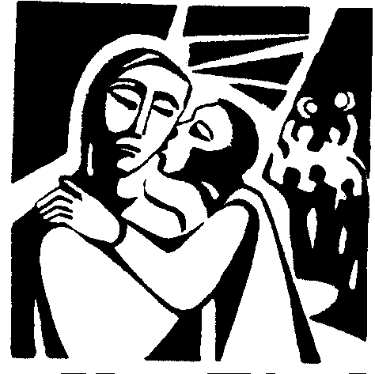
HOLY WEEK
Introduction
LEADER
Who knows the name of the week from Palm Sunday to Easter?

ALL
Holy Week

LEADER
During Holy Week we celebrate Palm Sunday with the blessing of palms, Holy Thursday by remembering the first Eucharist, Good Friday by remembering the death of Jesus on the cross, Holy Saturday by lighting the Easter Candle, and Easter by singing Alleluia’s again.

Leader explains each symbol, instructs all to say out loud the appropriate response after each reading and practices the responses with all.

Prayer
LEADER
Let us pray.
Loving God, open our hearts to the grace of Holy Week. Fill us with humility, reverence and gratitude for your Son Jesus, our Lord and Redeemer, who so generously made a great sacrifice for us. From Palm Sunday to Holy Saturday, help us keep Jesus in our hearts. We ask this through your Son, Jesus, who lives and reigns with you and the Holy Spirit, one God, forever and ever. adapted from www.Sadlier.com/Religion

ALL
Amen
Palm Sunday
READER 1
Jesus entered Jerusalem on a colt. People laid on the road palms they had cut in the fields. Everyone shouted, “Hosanna to the Son of David”.
adapted from Mark 11: 7-9

ALL
Hosanna! Hosanna!

Bread and Chalice of the Last Supper
READER 2
At dinner for the last time with his friends, Jesus blessed bread, broke it, and gave it to his disciples, saying, “Take and eat. This is my body, which will be given up for you.” Jesus also took a cup of wine, blessed it, and said, “Take and drink. This is the cup of my blood . . . which will be shed for you.” adapted from Luke 22:14–20

ALL
Thank you, Jesus!

Judas’ Silver Coins
READER 3
Judas, one of the apostles, was paid 30 silver coins to betray Jesus. He brought the soldiers to the Garden of Gethsemane and gave Jesus a kiss to show the soldiers who Jesus was. adapted from Luke 22:47–53

ALL
Ching! Ching!

Rooster
READER 4
After Jesus was taken by the soldiers, Peter was standing outside the court, and people began asking him if he, too, was a friend of Jesus. Peter, very afraid, denied it three times, and then a rooster crowed, as Jesus had predicted. adapted from Luke 22:54–65

ALL
Cock-a-Doodle-Do!

Crown of Thorns
READER 5
To torture Jesus, the soldiers put a crown of thorns on his head and mocked him by saying, “All Hail, King of the Jews!”
adapted from Luke 22:54–65
ALL
Ouch!

Cross
READER 6
Pilate condemned Jesus to death on a cross. adapted from John 19: 15-16

ALL
Shhh!!!!!!!!!!

INRI
READER 7
Pilate also had an inscription written and put on the cross. It read, “Jesus the Nazorean, the King of the Jews.” adapted from John 19: 19

ALL
Jesus! Jesus!

Fire of the Easter Candle
READER 8
Jesus said to them, “I am the light of the world. Whoever follows me will not walk in darkness, but will have the light of life. adapted from John 8: 12

ALL
Ooh! Aah!

Prayer
LEADER
Let us pray.
Loving God, you have given us a model of humility, Our Savior, Jesus, who died on the Cross. Grant us the grace to live the lessons Jesus

has given us in his Passion and to share in His resurrection. We ask this through your Son, Jesus, who lives and reigns with you and the Holy Spirit, one God, forever and ever.
adapted from the words of Pope Pius XII On the Sacred Liturgy

ALL
Amen.

Our Father
LEADER
Let us pray with the words that Jesus taught us.
ALL
Our Father …

Blessing
LEADER
May almighty God bless us in the name of the Father, Son, and Holy Spirit.

ALL

Amen

Song: Were You There (Ritual Song #570 vv.1-2)

