December GIFT - Home Work

Families should do the homework for the month BEFORE the GIFT session so that everyone will be prepared.

- Learn about Our Lady of Guadalupe and Juan Diego– watch or read

https://www.youtube.com/watch?v=KKgsZwRwbkE

Our Lady of Guadalupe
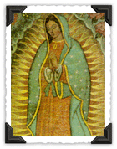
Feast Day: December 12
We celebrate the feast of Our Lady of Guadalupe on December 9. Our Blessed Mother appeared to a fifty-five year old Indian, Juan Deigo on December 9, 1531.
Juan was going to Mass early one morning when Our Lady stopped him as he was making his way down Tepyac Hill. Mary asked him to go to the bishop and tell him that she wanted a great church built on the very spot where she was standing.
Juan was very troubled. He wanted with all his heart to do what the Lady commanded. But how could he approach the bishop? How could anyone believe such an unusual request?
Juan Diego went to the bishop. The bishop did not believe his story. He did not want to offend Juan and told him to ask the Lady for a sign the next time he met her.
Juan was caught in the middle. The Lady knew what she wanted; the bishop had the power to make her wish come true, but he wanted proof.
On December 12, early in the morning, Juan Diego was hurrying along the path. His uncle was dying and he was going to get the priest. Juan had no time to waste and did not want to meet the lady so he took another route.
But Mary appeared again to Juan and told him that his uncle was better. In fact, Juan found out a little later that Our Lady had for a moment appeared to his uncle and he was immediately cured.
The Lady asked Juan to go back to the bishop. She wanted him to build a church. Juan remembered the bishop's request and asked Mary for a sign. Mary sent Juan into the rocky area nearby and told him to gather the roses that were there.
Juan was confused. He knew there were no roses. It was winter, there was snow on the ground and the bushes were bare. But Juan did as he was told and there really were roses, beautiful roses. Excited, Juan picked them all and went to the bishop.
He carried them carefully in his tilma (cloak). Juan clutched his cloak and made his way into the room where the bishop was. Slowly he let down his cloak and the beautiful roses, fresh and wet with dew, fell to the floor.
Juan smiled but was shocked when the bishop and his attendants knelt down in front of him. He followed the bishop's eyes that were staring at his cloak. And then he saw her, the picture of his beautiful lady, glowing on his tilma.
Her image was life-size, exactly as she had appeared. The bishop had received his sign and Mary would have her church.
Today a great church, called a basilica, stands on the spot where Our Lady of Guadalupe came to her people. Our Lady of Guadalupe was named patroness of Mexico and is also patroness of Latin America and the Philippines.

Blessed Juan Diego
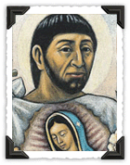
Feast Day: December 09
Born: 1474 :: Died: 1548
Juan Diego was born in Mexico and lived a simple life as a weaver, farmer and laborer.
On December 9, 1531, Juan rose before dawn to walk fifteen miles to Mexico City to attend daily Mass. As he passed Tepeyac Hill, he heard music and saw a glowing cloud encircled by a rainbow. A woman's voice called him to the top of the hill.
There he saw a beautiful young woman dressed like an Aztec princess. She said she was the Virgin Mary and Mother of the true God. She asked Juan to tell the bishop to build a church on that site, so she could be present to help and defend those were suffering and in pain.
After Juan's mission was completed, he became a hermit. He spent the rest of his life in prayer and penance. His little hut was near the first chapel that was built on Tepeyac Hill. He was greatly respected and parents wished their children would grow up to be holy like Juan Diego.
Juan took care of the little church and met the pilgrims who began to come there to honor their Mother of Guadalupe. He would show them the miraculous tilma or cloak that preserves Mary's beautiful image.
The pope personally visited the magnificent church of Our Lady of Guadalupe and prayed there for all of the people of Mexico. He prayed especially for those who were killed during the terrible persecution of the Church in the early part of this century. An he prayed for all the pilgrims who come to this beautiful church with such faith in the Mother of God.

Discuss with your family:

- Where did Juan Diego live?
- What happened to Juan Diego? How did he meet Our Lady?
- Who is Our Lady of Guadalupe?
- Why did the Bishop eventually believe Juan Diego that he met Our Lady?
- What message did Our Lady have?
- How do you think Juan Diego felt being chosen by Our Lady of Guadalupe to deliver her message?

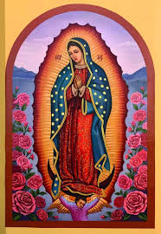
Our Lady of Guadalupe Worksheet
Name:_____________________________________

1. In 1531 miracles began to happen. Who appeared to humble Juan Diego?

2. When is the feast day of Our Lady of Guadalupe?

- Fill in the blank: Our Lady of Guadalupe is Patroness of the

3. What three miraculous signs convinced the Mexican people that the Catholic faith was true?

4.What was God's purpose in choosing Mary to appear to Juan?

5. What are some things we can learn from Juan Diego? How did he answer his call from God?

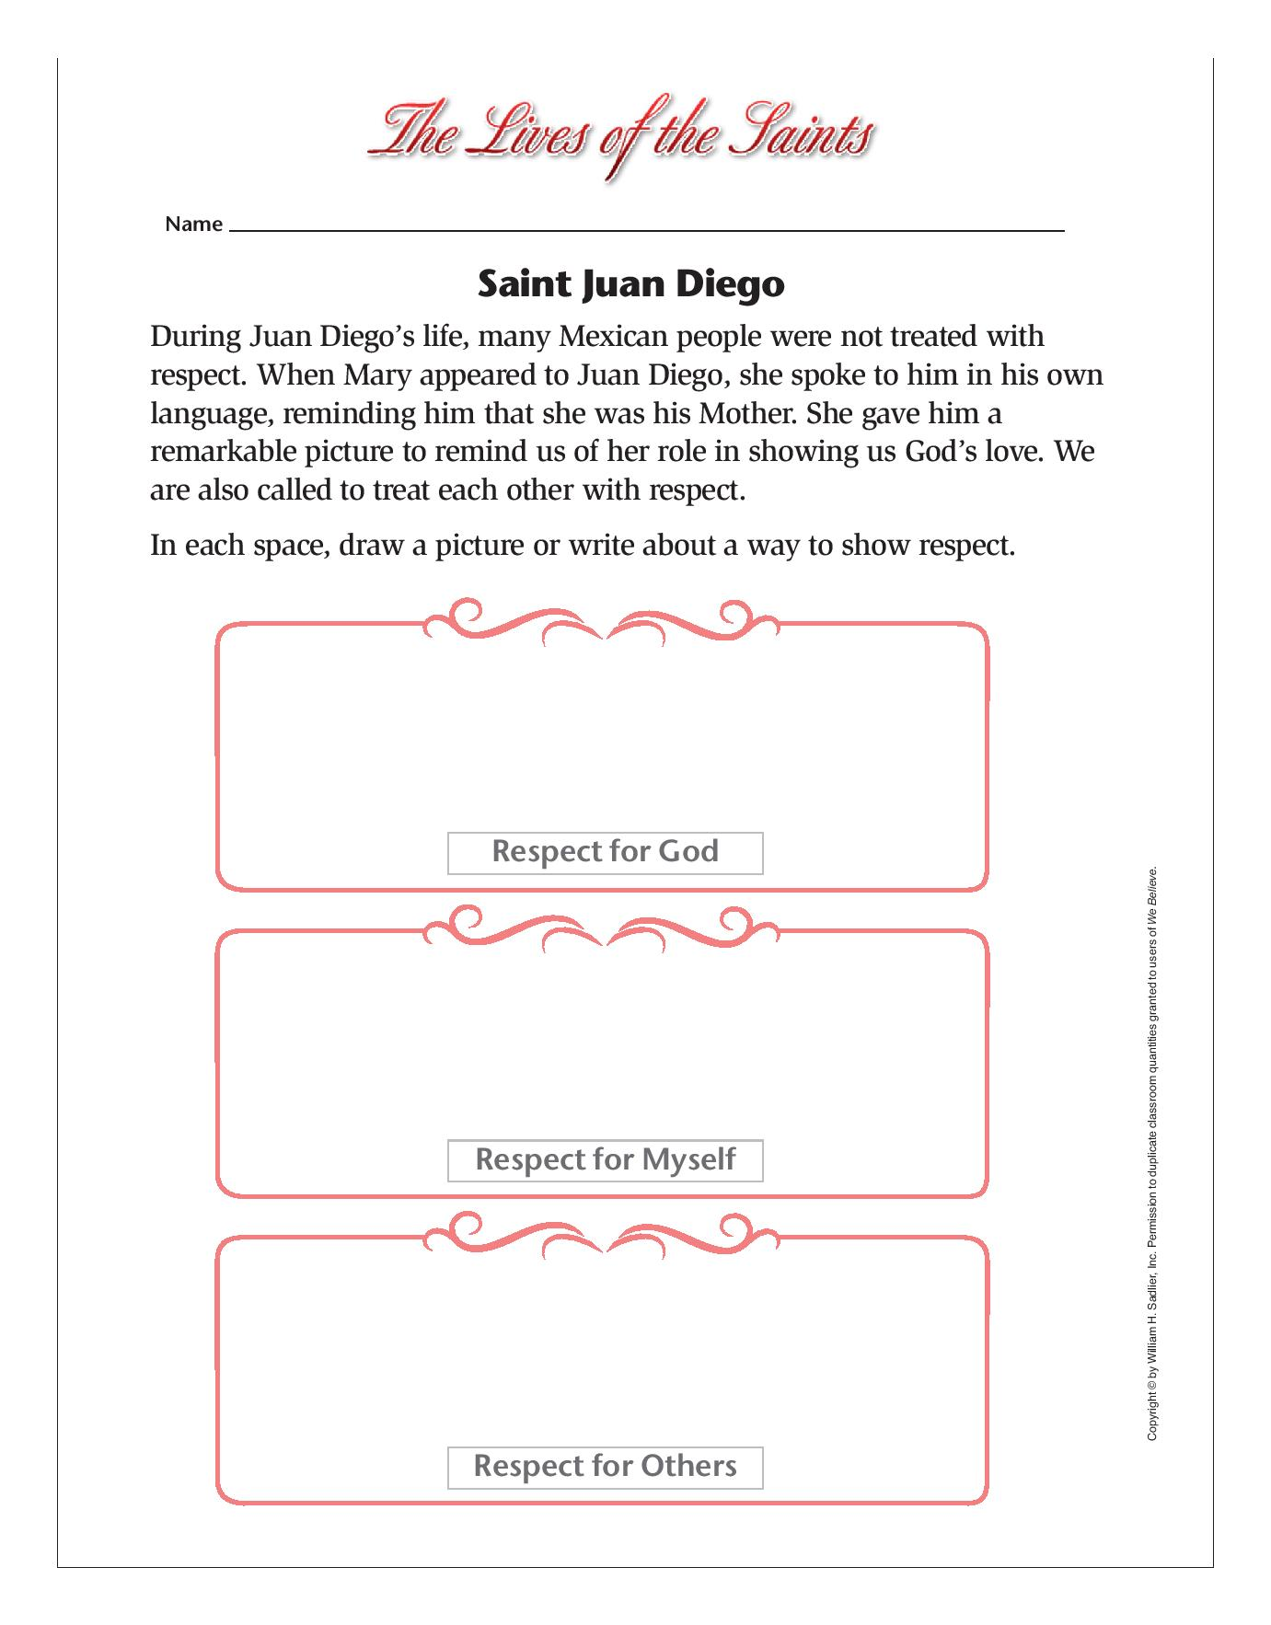

Learn More about the Image of Our Lady of Guadalupe

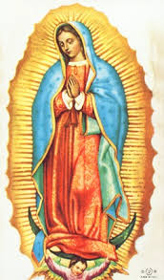

In 1999, Pope John Paul II named Our Lady of Guadalupe the patroness of the Americas. Why did he choose Our Lady of Guadalupe as our patroness? One reason would be her purpose in appearing to Juan Diego. Juan was a poor indigenous Mexican who had only recently converted to Catholicism when she appeared to him in 1531. She came to bring him a personal message of love, support and dignity. She told him he was worthy. She came in the image of a young Mexican woman with the same skin color he had. Can you imagine what that did to this poor native man? Our Lady was standing in solidarity with Juan Diego, but also with all those who were poor and oppressed.

She also brought a message of peace between the Spanish conquistadors and the indigenous Mexican people who were on the brink of war. She sought unity among all of God’s children.

Another way we can understand why Pope John Paul chose Mary as our patroness is by looking at her appearance.

To appreciate the power of Our Lady’s appearance for the people of Mexico—and of all the Americas—it’s important to talk about what Mary looked like when she appeared to Juan Diego. Many of the symbols which are part of her appearance made sense to Juan Diego and his people because of their familiarity with the Aztec culture. They would have readily understood why she was dressed the way she was.

Our Lady is standing in front of what look like rays of the sun. The Aztec people, who lived in Mexico long before Christianity came to that country, worshipped pagan gods. One god they greatly feared was the sun-god of war. Because Mary is standing in front of the sun, the Mexican people saw her as greater than their sun-god.

Our Lady’s foot is resting on a crescent moon. For the native people, that was a sign of her dominance over the feathered-serpent moon god of the Aztecs.

There are stars scattered across Our Lady’s mantle. The Aztec people worshipped the stars. Seeing them on her mantle would have made them see her as greater than the stars. Scientists have confirmed that the positioning of the stars on Our Lady matched the actual constellation of stars in the sky when she appeared to Juan Diego on December 12 of 1531.

Her mantle is a blue-green in color. That would have represented royalty to the people, who would then see her as a queen.

She wears a black cross on a brooch at her neck, representing her Son Jesus Christ. This would have told Juan Diego that her God was the same God he learned about from the Spanish missionaries. Juan Diego had become Catholic shortly before Mary’s appearance.

Our Lady has on a black belt. Juan Diego would have recognized this as the Aztec Maternity Belt, an indication that she was pregnant. And she was not just pregnant, but with the Son of God. The four-petal flower over her womb is symbolic of life, movement and deity. The center of the universe was being carried in her womb.

Our Lady’s hands are joined in prayer. This would have been crucial to Juan Diego’s understanding that she herself was not a god. She recognized one greater than her. She points her finger to the cross on her brooch. Our Lady’s role is always to lead us to Christ, her Son.

The design on her rose-colored garment holds a simple contour map of Mexico, indicating to the native people exactly where she appeared to Juan Diego. It also made them see her as the queen of the earth.

With your family, discuss the following questions:

- Why do you think Our Lady came as a pregnant indigenous woman?
- What do you think the most important aspect of her appearance was? Why?
- In light of Our Lady’s message and appearance, why do you think Pope John Paul chose her to be patroness of America?

